Chapter 15
Monopoly
Multiple Choice
1. Which of the following statements is correct?
a. A competitive firm is a price maker and a monopoly is a price taker.
b. A competitive firm is a price taker and a monopoly is a price maker.
c. Both competitive firms and monopolies are price takers.
d. Both competitive firms and monopolies are price makers.
ANSWER: b. A competitive firm is a price taker and a monopoly is a price maker.
TYPE: M DIFFICULTY: 1 SECTION: 15.1
2. Assuming that Jerry’s Bicycle Shop operates in a competitive market for bicycles, which of the following statements is(are) true?
(i) He chooses the price at which he sells his bicycles.
(ii) He chooses the quantity of bicycles that he supplies.
(iii) His market is characterized by one or more barriers to entry.
a. (i) only
b. (ii) only
c. (i) and (ii) only
d. (ii) and (iii) only
ANSWER: b. (ii) only
TYPE: M DIFFICULTY: 2 SECTION: 15.1
3. Angelo is a wholesale meatball distributor. He sells his meatballs to all the finest Italian restaurants in town. Nobody can make meatballs like Angelo. As a result, his is the only business in town that sells meatballs to restaurants. Assuming that Angelo is maximizing his profit, which of the following statements is true?
a. Meatball prices will be less than marginal cost.
b. Meatball prices will equal marginal cost.
c. Meatball prices will exceed marginal cost.
d. Meatball prices will be a function of supply and demand and will therefore oscillate around marginal costs.
ANSWER: c. Meatball prices will exceed marginal cost.
TYPE: M DIFFICULTY: 2 SECTION: 15.1
4. A monopoly’s marginal cost will
a. be less than its average fixed cost.
b. be less than the price per unit of its product.
c. exceed its marginal revenue.
d. equal its average total cost.
ANSWER: b. be less than the price per unit of its product.
TYPE: M DIFFICULTY: 2 SECTION: 15.1
5. Which of the following statements is (are) true of a monopoly?
(i) A monopoly has the ability to set the price of its product at whatever level it desires.
(ii) A monopoly’s total revenue will always increase when it increases the price of its product.
(iii) A monopoly can earn unlimited profits.
a. (i) only
b. (ii) only
c. (i) and (ii)
d. (ii) and (iii)
ANSWER: a. (i) only
TYPE: M DIFFICULTY: 2 SECTION: 15.1
6. Young Johnny inherited the only local cable TV company in town after his father passed away. The company is completely unregulated by the government and is therefore free to operate as it wishes. Assuming that Johnny understands the true power of his new monopoly, he is probably most excited about which of the following statements?
(i) He will be able to set the price of cable TV service at whatever level he wishes.
(ii) The customers will be forced to purchase cable TV service at whatever price he wants to set.
(iii) He will be able to achieve any profit level that he desires.
a. (i) only
b. (ii) only
c. (i) and (iii)
d. All of the above are correct.
ANSWER: a. (i) only
TYPE: M DIFFICULTY: 2 SECTION: 15.1
7. Which of the following is an example of a barrier to entry?
(i) A key resource is owned by a single firm.
(ii) The costs of production make a single producer more efficient than a large number of producers.
(iii) The government has given the existing monopoly the exclusive right to produce the good.
a. (i) and (ii)
b. (ii) and (iii)
c. (i) only
d. All of the above are correct.
ANSWER: d. All of the above are correct.
TYPE: M DIFFICULTY: 1 SECTION: 15.1
8. To define a monopoly, we cite the following characteristics:
(i) The firm is the sole seller of its product.
(ii) The firm’s product does not have close substitutes.
(iii) The firm generates a large economic profit.
(iv) The firm is located in a small geographic market.
a. (i) and (ii)
b. (i) and (iii)
c. (ii) and (iv)
d. All of the above are correct.
ANSWER: a. (i) and (ii)
TYPE: M DIFFICULTY: 2 SECTION: 15.1
9. A fundamental source of monopoly market power arises from
a. perfectly elastic demand.
b. perfectly inelastic demand.
c. barriers to entry.
d. availability of "free" natural resources, such as water or air.
ANSWER: c. barriers to entry.
TYPE: M DIFFICULTY: 2 SECTION: 15.1
10. Because monopoly firms do not have to compete with other firms, the outcome in a market with a monopoly is often
a. not in the best interest of society.
b. one that fails to maximize total economic well-being.
c. inefficient.
d. All of the above are correct.
ANSWER: d. All of the above are correct.
TYPE: M DIFFICULTY: 2 SECTION: 15.1
11. A natural monopoly occurs when
a. the product is sold in its natural state (such as water or diamonds).
b. there are economies of scale over the relevant range of output.
c. the firm is characterized by a rising marginal cost curve.
d. production requires the use of free natural resources, such as water or air.
ANSWER: b. there are economies of scale over the relevant range of output.
TYPE: M DIFFICULTY: 2 SECTION: 15.1
12. An industry is a natural monopoly when
(i) government assists the firm in maintaining the monopoly.
(ii) a single firm owns a key resource.
(iii) a single firm can supply a fixed number of goods or services at a smaller cost than could two or more firms.
a. (i) only
b. (iii) only
c. (i) and (ii)
d. (ii) and (iii)
ANSWER: b. (iii) only
TYPE: M DIFFICULTY: 2 SECTION: 15.1
13. When a natural monopoly exists, it is
a. always cost effective for government-owned firms to produce the product.
b. never cost effective for one firm to produce the product.
c. always cost effective for two or more private firms to produce the product.
d. never cost effective for two or more private firms to produce the product.
ANSWER: d. never cost effective for two or more private firms to produce the product.
TYPE: M DIFFICULTY: 2 SECTION: 15.1
14. The defining characteristic of a natural monopoly is
a. constant marginal cost over the relevant range of output.
b. economies of scale over the relevant range of output.
c. constant returns to scale over the relevant range of output.
d. diseconomies of scale over the relevant range of output.
ANSWER: b. economies of scale over the relevant range of output.
TYPE: M DIFFICULTY: 2 SECTION: 15.1
15. Natural monopolies differ from other forms of monopoly because they
a. are not subject to barriers to entry.
b. are not regulated by government.
c. generally don't make a profit.
d. are generally not worried about competition eroding their monopoly position in the market.
ANSWER: d. are generally not worried about competition eroding their monopoly position in the market.
TYPE: M DIFFICULTY: 2 SECTION: 15.1
16. Patent and copyright laws are major sources of
a. natural monopolies.
b. government-created monopolies.
c. resource monopolies.
d. None of the above are correct.
ANSWER: b. government-created monopolies.
TYPE: M DIFFICULTY: 1 SECTION: 15.1
17. Encouraging firms to invest in research and development and individuals to engage in creative endeavors such as writing novels is one justification for
a. resource monopolies.
b. natural monopolies.
c. government-created monopolies.
d. breaking up monopolies into smaller firms.
ANSWER: c. government-created monopolies.
TYPE: M DIFFICULTY: 1 SECTION: 15.1
18. When a firm's average total cost curve continually declines, the firm is a
a. government-created monopoly.
b. natural monopoly.
c. revenue monopoly.
d. All of the above are correct.
ANSWER: b. natural monopoly.
TYPE: M DIFFICULTY: 1 SECTION: 15.1
19. Which of the following scenarios best represents a monopoly situation?
a. Bill and Tom work separately from one another but both sell a very rare form of the same diamond. They are the only sellers of this type of diamond in town.
b. Tom owns a fishing tackle shop in Miami, Florida, in which he sells the top-of-the-line fishing equipment.
c. Bill owns the only grocery store in a small community that lies 200 miles from the nearest city.
d. None of the above adequately represents a monopoly.
ANSWER: c. Bill owns the only grocery store in a small community that lies 200 miles from the nearest city.
TYPE: M DIFFICULTY: 2 SECTION: 15.1
20. The simplest way for a monopoly to arise is for a single firm to
a. decrease its prices without consulting other firms.
b. decrease production to increase demand for its product.
c. jointly make pricing decisions with other firms.
d. own a key resource.
ANSWER: d. own a key resource.
TYPE: M DIFFICULTY: 1 SECTION: 15.1

Use the following information to answer question 21 through 23.

Consider the market for water in a small town in the Old West. Assume that the only source of water is the underground aquifer that lies directly below the town. Wells are used to supply water to the entire town.
21. If dozens of residents have their own wells, which of the following statements most adequately describes the behavior of sellers of water?
a. Since water is a necessity of life, there will be no decline in the quantity of water consumed, regardless of how high the price is raised.
b. Sellers will be able to charge a premium for the water.
c. The price of a gallon of water will exceed its marginal cost.
d. The price of a gallon of water will be driven to equal its marginal cost.
ANSWER: d. The price of a gallon of water will be driven to equal its marginal cost.
TYPE: M DIFFICULTY: 2 SECTION: 15.1
22. Suppose only one resident owns all the wells in town. Which of the following statements is most likely going to be true of the market for water?
a. The price of a gallon of water will be driven to equal its marginal cost.
b. The price of a gallon of water will exceed its marginal cost.
c. Since water is a necessity of life, there will be no decline in the quantity of water consumed, regardless of how high the price is raised.
d. The seller will be able to earn unlimited profit.
ANSWER: b. The price of a gallon of water will exceed its marginal cost.
TYPE: M DIFFICULTY: 2 SECTION: 15.1
23. Assume that Jack is the sole owner of all the wells in town. He decides to move to a more suitable climate and sells the wells to a couple of dozen different town residents.
a. The town residents will likely be better off.
b. The price of water is likely to fall.
c. The individual water sellers will not have as much pricing power as Jack had.
d. All of the above are correct.
ANSWER: d. All of the above are correct.
TYPE: M DIFFICULTY: 2 SECTION: 15.1
24. In practice, monopolies rarely arise from exclusive ownership of a resource because
a. actual economies are quite large.
b. the natural scope of many such markets is often worldwide.
c. few firms own a resource for which there are no close substitutes.
d. All of the above are correct.
ANSWER: d. All of the above are correct.
TYPE: M DIFFICULTY: 2 SECTION: 15.1
25. A government-created monopoly arises when
a. government spending in a certain industry gives rise to monopoly power.
b. the government exercises its market control by encouraging competition among sellers.
c. the government gives a firm the exclusive right to sell some good or service.
d. All of the above could qualify as government-created monopolies.
ANSWER: c. the government gives a firm the exclusive right to sell some good or service.
TYPE: M DIFFICULTY: 2 SECTION: 15.1
26. Allowing an inventor to have the exclusive rights to market her new invention will lead to
(i) a product that is priced higher than it would be without the exclusive rights.
(ii) desirable behavior in the sense that inventors are encouraged to invent.
(iii) higher profits for the inventor.
a. (i) and (ii)
b. (ii) and (iii)
c. (i) and (iii)
d. All of the above are correct.
ANSWER: d. All of the above are correct.
TYPE: M DIFFICULTY: 2 SECTION: 15.1
27. Drug companies are allowed to be monopolists in the drugs they discover in order to
a. allow drug companies to charge a price that is equal to their marginal cost.
b. discourage new firms from entering the drug market.
c. encourage research.
d. All of the above are correct.
ANSWER: c. encourage research.
TYPE: M DIFFICULTY: 2 SECTION: 15.1
28. Authors are allowed to be monopolists in the sale of their books in order to
a. encourage authors to write more and better books.
b. correct for the negative externalities that the internet and television impose.
c. satisfy literary advocacy groups that exercise their lobbying power.
d. promote a society in which people think for themselves and learn from whichever books they please.
ANSWER: a. encourage authors to write more and better books.
TYPE: M DIFFICULTY: 2 SECTION: 15.1
29. Which of the following statements is true about patents and copyrights?
(i) They both have benefits and costs.
(ii) They lead to higher prices.
(iii) They enhance the ability of monopolists to earn above-average profits.
a. (i) and (ii)
b. (ii) and (iii)
c. (ii) only
d. All of the above are correct.
ANSWER: d. All of the above are correct.
TYPE: M DIFFICULTY: 2 SECTION: 15.1

Use the figure to answer question 30 and 31

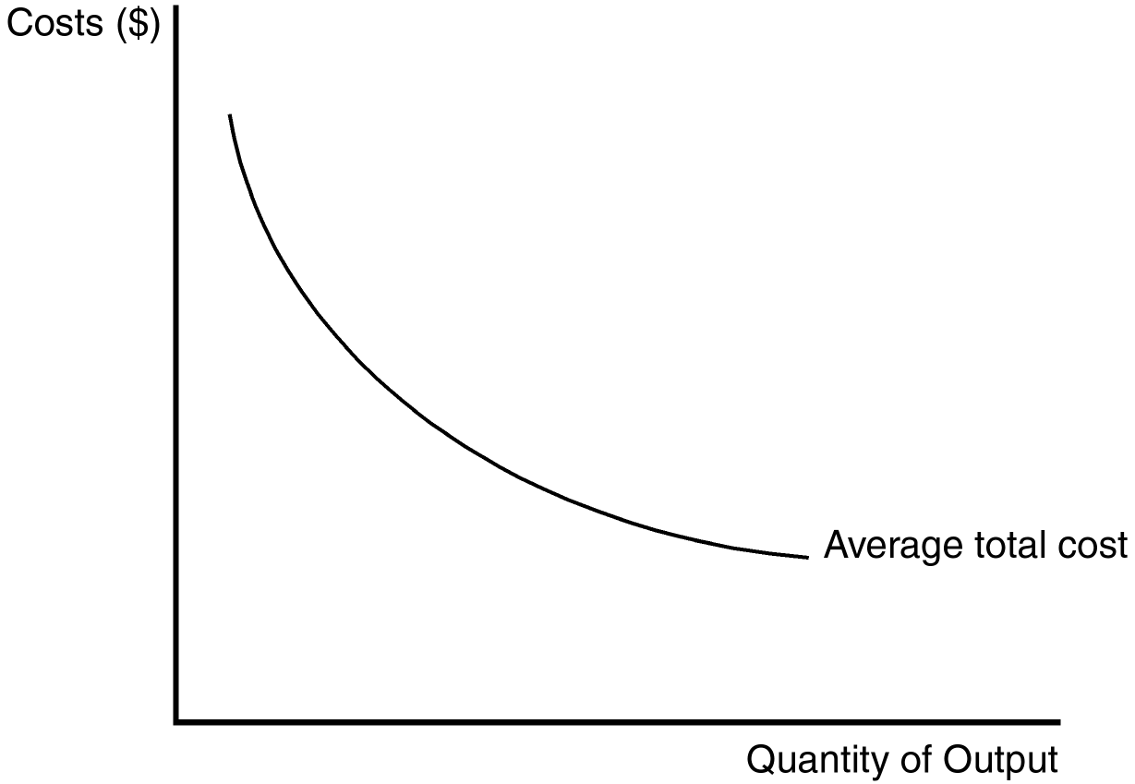

30. The shape of the average total cost curve reveals information about the nature of the barrier to entry that might exist in a monopoly market. Which of the following monopoly types best coincides with the figure?
a. ownership of a key resource by a single firm
b. natural monopoly
c. government-created monopoly
d. None of the above are correct.
ANSWER: b. natural monopoly
TYPE: M DIFFICULTY: 2 SECTION: 15.1
31. The shape of the average total cost curve in the figure suggests an opportunity for a profit-maximizing monopolist to take advantage of
a. economies of scale.
b. diseconomies of scale.
c. diminishing marginal product.
d. increasing marginal cost.
ANSWER: a. economies of scale.
TYPE: M DIFFICULTY: 1 SECTION: 15.1
32. In view of what we know about the relationship between average total cost and marginal cost, the marginal cost curve for this firm
a. must lie entirely above the average total cost curve.
b. must lie entirely below the average total cost curve.
c. must be upward sloping.
d. does not exist.
ANSWER: b. must lie entirely below the average total cost curve.
TYPE: M DIFFICULTY: 3 SECTION: 15.1
33. When an industry is a natural monopoly,
a. it is characterized by constant returns to scale.
b. it is characterized by diseconomies of scale.
c. a larger number of firms may lead to a lower average cost.
d. a larger number of firms will lead to a higher average cost.
ANSWER: d. a larger number of firms will lead to a higher average cost.
TYPE: M DIFFICULTY: 2 SECTION: 15.1
34. If the distribution of water is a natural monopoly, then
(i) multiple firms will each have to pay large fixed costs to develop their own network of pipes.
(ii) allowing for competition among different firms in the water-distribution industry is efficient.
(iii) a single firm can serve the market at the lowest possible average total cost.
a. (i) and (ii)
b. (ii) and (iii)
c. (i) and (iii)
d. (i) only
ANSWER: c. (i) and (iii)
TYPE: M DIFFICULTY: 2 SECTION: 15.1
35. A firm that is a natural monopoly
a. is not likely to be concerned about new entrants eroding its monopoly power.
b. is taking advantage of economies of scale.
c. would experience a higher average total cost if more firms entered the market.
d. All of the above are correct.
ANSWER: d. All of the above are correct.
TYPE: M DIFFICULTY: 2 SECTION: 15.1
36. Additional firms often do not try to compete with a natural monopoly because
a. they fear retaliation in the form of pricing wars from the natural monopolist.
b. they are unsure of the size of the market in general.
c. they know they cannot achieve the same low costs that the monopolist enjoys.
d. the natural monopoly doesn’t make a huge profit.
ANSWER: c. they know they cannot achieve the same low costs that the monopolist enjoys.
TYPE: M DIFFICULTY: 2 SECTION: 15.1
37. The laws governing patents and copyrights
a. can lead to monopolies.
b. are intended to serve private interests, not the public interest.
c. have costs, but no benefits.
d. All of the above are correct.
ANSWER: a. can lead to monopolies.
TYPE: M DIFFICULTY: 2 SECTION: 15.1
38. The De Beers diamond monopoly is a classic example of a monopoly that
a. is government-created.
b. arises from the ownership of a key resource.
c. results in very little advertising of the product that the monopolist produces.
d. was broken up by the government a long time ago.
ANSWER: b. arises from the ownership of a key resource.
TYPE: M DIFFICULTY: 2 SECTION: 15.1

Use the information below to answer questions 39 and 40.

Consider a transportation corporation named C.R. Evans that has just completed the development of a new subway system in a medium-sized town in the Northwest. Currently, there are plenty of seats on the subway, and it is never crowded. Its capacity far exceeds the needs of the city. After just a few years of operation, the shareholders of C.R. Evans experienced incredible rates of return on their investment, due to the profitability of the corporation.
39. Which of the following statements are most likely to be true?
(i) New entrants to the market know they will earn a smaller piece of the market than C.R. Evans currently has.
(ii) C.R. Evans is most likely experiencing increasing average total cost.
(iii) C.R. Evans is a natural monopoly.
a. (i) and (ii)
b. (ii) and (iii)
c. (i) and (iii)
d. All of the above are correct.
ANSWER: c. (i) and (iii)
TYPE: M DIFFICULTY: 2 SECTION: 15.1
40. C.R. Evans may continue to be a monopolist in the subway transportation industry only if
a. population growth leads to an overcrowding of the subway cars.
b. there are no new entrants to the market.
c. demand for transportation services decreases.
d. All of the above are correct.
ANSWER: b. there are no new entrants to the market.
TYPE: M DIFFICULTY: 2 SECTION: 15.1
41. The fundamental cause of monopoly is
a. incompetent management in competitive firms.
b. the zero-profit feature of long-run equilibrium in competitive markets.
c. advertising.
d. barriers to entry.
ANSWER: d. barriers to entry.
TYPE: M DIFFICULTY: 1 SECTION: 15.1
42. Which of the following items is a primary source of barriers to entry?
a. The costs of production make a single firm more efficient than a large number of firms.
b. A single firm hires all the people who have the management skills that are important in the industry.
c. Contracts among firms prohibit them from competing with one another in the production and sale of certain products.
d. All of the above are correct.
ANSWER: a. The costs of production make a single firm more efficient than a large number of firms.
TYPE: M DIFFICULTY: 2 SECTION: 15.1
43. A firm that has a monopoly on water (which is a necessity) can charge a high price for water
a. only if the marginal cost of producing water is high.
b. even if the marginal cost of producing water is low.
c. only if the firm is a natural monopoly.
d. even if the demand for water is low.
ANSWER: b. even if the marginal cost of producing water is low.
TYPE: M DIFFICULTY: 2 SECTION: 15.1
44. Suppose most people regard emeralds, rubies, and sapphires as close substitutes for diamonds. Then DeBeers, the large diamond company, has
a. less incentive to advertise than it would otherwise have.
b. less market power than it would otherwise have.
c. more control over the price of diamonds than it would otherwise have.
d. higher profits than it would otherwise have.
ANSWER: b. less market power than it would otherwise have.
TYPE: M DIFFICULTY: 2 SECTION: 15.1
45. A benefit to society of the patent and copyright laws is that those laws
a. help to keep prices down.
b. help to prevent a single firm from acquiring ownership of a key resource.
c. encourage creative activity.
d. discourage excessive amounts of output of certain products.
ANSWER: c. encourage creative activity.
TYPE: M DIFFICULTY: 1 SECTION: 15.1
46. When a single firm can supply a product to an entire market at a smaller cost than could two or more firms, the industry is called a
a. resource industry.
b. exclusive industry.
c. government monopoly.
d. natural monopoly.
ANSWER: d. natural monopoly.
TYPE: M DIFFICULTY: 1 SECTION: 15.1
47. A natural monopoly arises when
a. there are constant returns to scale over the relevant range of output.
b. there are economies of scale over the relevant range of output.
c. one firm owns a key natural resource.
d. the government gives a single firm the exclusive right to produce a particular good or service.
ANSWER: b. there are economies of scale over the relevant range of output.
TYPE: M DIFFICULTY: 1 SECTION: 15.1
48. When a firm has a natural monopoly, the firm’s
a. marginal cost always exceeds its average total cost.
b. total cost curve is horizontal.
c. average total cost curve is downward sloping.
d. All of the above are correct.
ANSWER: c. average total cost curve is downward sloping.
TYPE: M DIFFICULTY: 2 SECTION: 15.1
49. It is possible for a natural monopoly to evolve into a competitive market
a. as a market expands.
b. as patent and copyright laws change.
c. as technological advances give rise to economies of scale.
d. None of the above are correct; it is not possible for a natural monopoly to evolve into a competitive market.
ANSWER: a. as a market expands.
TYPE: M DIFFICULTY: 2 SECTION: 15.1
50. The key difference between a competitive firm and a monopoly firm is the ability to select
a. the level of competition in the market.
b. the level of production.
c. inputs in the production process.
d. the price of its output.
ANSWER: d. the price of its output.
TYPE: M DIFFICULTY: 2 SECTION: 15.2
51. The market demand curve for a monopolist is typically
a. unitary elastic at the point of profit maximization.
b. downward sloping.
c. horizontal.
d. vertical.
ANSWER: b. downward sloping.
TYPE: M DIFFICULTY: 2 SECTION: 15.2
52. When a firm operates under conditions of monopoly, its price is
a. not constrained.
b. constrained by marginal cost.
c. constrained by demand.
d. constrained only by its social agenda.
ANSWER: c. constrained by demand.
TYPE: M DIFFICULTY: 2 SECTION: 15.2
53. In order to sell more of its product, a monopolist must
a. sell to the government.
b. sell in international markets.
c. lower its price.
d. use its market power to force up the price of complementary products.
ANSWER: c. lower its price.
TYPE: M DIFFICULTY: 2 SECTION: 15.2
54. A natural monopolist's ability to price its product is
a. constrained by the market demand curve.
b. constrained by market supply.
c. not affected by market demand.
d. enhanced by regulatory control of the government.
ANSWER: a. constrained by the market demand curve.
TYPE: M DIFFICULTY: 2 SECTION: 15.2
55. Economists assume that monopolists behave as
a. cost minimizers.
b. profit maximizers.
c. price maximizers.
d. All of the above are correct.
ANSWER: b. profit maximizers.
TYPE: M DIFFICULTY: 2 SECTION: 15.2
56. A monopolist's average revenue is always
a. equal to marginal revenue.
b. greater than the price of its product.
c. equal to the price of its product.
d. less than the price of its product.
ANSWER: c. equal to the price of its product.
TYPE: M DIFFICULTY: 2 SECTION: 15.2
57. If a profit-maximizing monopolist faces a downward-sloping market demand curve, its
a. average revenue is less than the price of the product.
b. average revenue is less than marginal revenue.
c. marginal revenue is less than the price of the product.
d. marginal revenue is greater than the price of the product.
ANSWER: c. marginal revenue is less than the price of the product.
TYPE: M DIFFICULTY: 2 SECTION: 15.2
58. When a monopolist increases the number of units it sells, there are two effects on revenue. They are the
a. demand effect and the supply effect.
b. competition effect and the cost effect.
c. competitive effect and the monopoly effect.
d. output effect and the price effect.
ANSWER: d. output effect and the price effect.
TYPE: M DIFFICULTY: 2 SECTION: 15.2
59. Which of the following statements is (are) true of monopolies?
a. Monopolies are constrained by market demand.
b. Monopolies benefit from barriers to entry.
c. Monopolies have the ability to set the prices of their products.
d. All of the above are correct.
ANSWER: d. All of the above are correct.
TYPE: M DIFFICULTY: 2 SECTION: 15.2
60. For a monopolist, marginal revenue is
a. positive when the demand effect is greater than the supply effect.
b. positive when the monopoly effect is greater than the competitive effect.
c. negative when the price effect is greater than the output effect.
d. negative when the output effect is greater than the price effect.
ANSWER: c. negative when the price effect is greater than the output effect.
TYPE: M DIFFICULTY: 3 SECTION: 15.2
61. A profit-maximizing monopolist will produce the level of output at which
a. average revenue is equal to average total cost.
b. average revenue is equal to marginal cost.
c. marginal revenue is equal to marginal cost.
d. total revenue is equal to opportunity cost.
ANSWER: c. marginal revenue is equal to marginal cost.
TYPE: M DIFFICULTY: 2 SECTION: 15.2
62. For a profit-maximizing monopolist,
a. P > MR = MC.
b. P = MR = MC.
c. P > MR > MC.
d. MR < MC < P.
ANSWER: a. P > MR = MC.
TYPE: M DIFFICULTY: 2 SECTION: 15.2
63. Because a monopolist is the sole producer in its market, it can necessarily alter the price of its good
(i) without affecting the quantity sold.
(ii) without affecting its average total cost.
(iii) by adjusting the quantity it supplies to the market.
a. (ii) only
b. (iii) only
c. (i) and (ii)
d. (i) and (iii)
ANSWER: b. (iii) only
TYPE: M DIFFICULTY: 2 SECTION: 15.2
64. Competitive firms have
a. downward-sloping demand curves and they can sell as much output as they desire at the market price.
b. downward-sloping demand curves and they can sell only a limited quantity of output at each price.
c. horizontal demand curves and they can sell as much output as they desire at the market price.
d. horizontal demand curves and they can sell only a limited quantity of output at each price.
ANSWER: c. horizontal demand curves and they can sell as much output as they desire at the market price.
TYPE: M DIFFICULTY: 2 SECTION: 15.2
65. Monopoly firms have
a. downward-sloping demand curves and they can sell as much output as they desire at the market price.
b. downward-sloping demand curves and they can sell only a limited quantity of output at each price.
c. horizontal demand curves and they can sell as much output as they desire at the market price.
d. horizontal demand curves and they can sell only a limited quantity of output at each price.
ANSWER: b. downward-sloping demand curves and they can sell only a limited quantity of output at each price.
TYPE: M DIFFICULTY: 2 SECTION: 15.2
66. Because many good substitutes exist for a competitive firm’s product, the demand curve that it faces is
a. unit-elastic.
b. perfectly inelastic.
c. perfectly elastic.
d. inelastic only over a certain region.
ANSWER: c. perfectly elastic.
TYPE: M DIFFICULTY: 2 SECTION: 15.2
67. When a monopolist decreases the price of its good, consumers
a. continue to buy the same amount.
b. buy more.
c. buy less.
d. may buy more or less, depending on the price elasticity of demand.
ANSWER: b. buy more.
TYPE: M DIFFICULTY: 1 SECTION: 15.2
68. When a monopolist increases the amount of output that it produces and sells, the price of its output
a. stays the same.
b. increases.
c. decreases.
d. may increase or decrease depending on the price elasticity of demand.
ANSWER: c. decreases.
TYPE: M DIFFICULTY: 2 SECTION: 15.2
69. When a monopolist increases the amount of output that it produces and sells, its average revenue
a. increases and its marginal revenue increases.
b. increases and its marginal revenue decreases.
c. decreases and its marginal revenue increases.
d. decreases and its marginal revenue decreases.
ANSWER: d. decreases and its marginal revenue decreases.
TYPE: M DIFFICULTY: 2 SECTION: 15.2
70. Which of the following is an impossible feat for a monopolist to accomplish?
a. control the price of its good
b. charge a higher price and continue to sell the same quantity
c. operate at a point on the upper half of the demand curve
d. All of the above are correct.
ANSWER: b. charge a higher price and continue to sell the same quantity
TYPE: M DIFFICULTY: 2 SECTION: 15.2
Use the following table of numbers to answer questions 71 through 75.
Total Average Marginal
Quantity Price Revenue Revenue Revenue
1 35 35
2 64 32 29
3 29
4 17
5 23 11
6 120
7 17 -1
8 -7
9 99 11 -13
10 8 80
71. If the monopolist sells 8 units of its product, how much total revenue will it receive from the sale?
a. 40
b. 112
c. 164
d. It cannot be determined from the information provided.
ANSWER: b. 112
TYPE: M DIFFICULTY: 2 SECTION: 15.2
72. If the monopolist wants to maximize its revenue, how many units of its product should it sell?
a. 4
b. 5
c. 6
d. 8
ANSWER: c. 6
TYPE: M DIFFICULTY: 2 SECTION: 15.2
73. When 4 units of output are produced and sold, what is average revenue?
a. 17
b. 21
c. 23
d. 26
ANSWER: d. 26
TYPE: M DIFFICULTY: 2 SECTION: 15.2
74. What is the marginal revenue for the monopolist for the sixth unit sold?
a. 3
b. 5
c. 11
d. 17
ANSWER: b. 5
TYPE: M DIFFICULTY: 2 SECTION: 15.2
75. Assume this monopolist’s marginal cost is constant at $11. What quantity of output (Q) will it produce and what price (P) will it charge?
a. Q = 4, P = $27
b. Q = 4, P = $25
c. Q = 5, P = $23
d. Q = 7, P = $17
ANSWER: c. Q = 5, P = $23
TYPE: M DIFFICULTY: 2 SECTION: 15.2
76. Marginal revenue for a monopolist is computed as
a. average revenue divided by quantity sold.
b. average revenue times quantity divided by price.
c. total revenue divided by quantity sold.
d. change in total revenue per one unit increase in quantity sold.
ANSWER: d. change in total revenue per one unit increase in quantity sold.
TYPE: M DIFFICULTY: 2 SECTION: 15.2
77. A monopolist’s marginal revenue is less than price because
(i) to sell additional units of the good, the price charged on all units must decrease.
(ii) with the sale of an additional unit, the monopolist receives less revenue for each of the previous units it planned to sell.
(iii) of the upward-sloping average revenue curve.
a. (i) and (ii)
b. (ii) and (iii)
c. (i) and (iii)
d. All of the above are correct.
ANSWER: a. (i) and (ii)
TYPE: M DIFFICULTY: 3 SECTION: 15.2
78. Which of the following statements is true?
(i) When a competitive firm sells an additional unit of output, its revenue increases by an amount less than the price.
(ii) When a monopoly firm sells an additional unit of output, its revenue increases by an amount less than the price.
(iii) Average revenue is the same as price for both competitive and monopoly firms.
a. (i) only
b. (iii) only
c. (i) and (ii)
d. (ii) and (iii)
ANSWER: d. (ii) and (iii)
TYPE: M DIFFICULTY: 3 SECTION: 15.2
79. For a monopoly firm, which of the following equalities is true?
a. price = marginal revenue
b. price = average revenue
c. price = total revenue
d. None of the above are correct.
ANSWER: b. price = average revenue
TYPE: M DIFFICULTY: 2 SECTION: 15.2
80. The marginal revenue curve for a monopoly firm starts at the same point on the vertical axis as the
(i) average revenue curve.
(ii) marginal cost curve.
(iii) demand curve.
a. (i) only
b. (i) and (ii)
c. (i) and (iii)
d. (ii) only
ANSWER: c. (i) and (iii)
TYPE: M DIFFICULTY: 2 SECTION: 15.2
81. Marginal revenue can become negative for
a. both competitive and monopoly firms.
b. competitive firms, but not for monopoly firms.
c. monopoly firms, but not for competitive firms.
d. neither competitive nor monopoly firms.
ANSWER: c. monopoly firms, but not for competitive firms.
TYPE: M DIFFICULTY: 2 SECTION: 15.2

The figure below reflects the cost and revenue structure for a monopoly firm. Use it to answer questions 82 through 89.

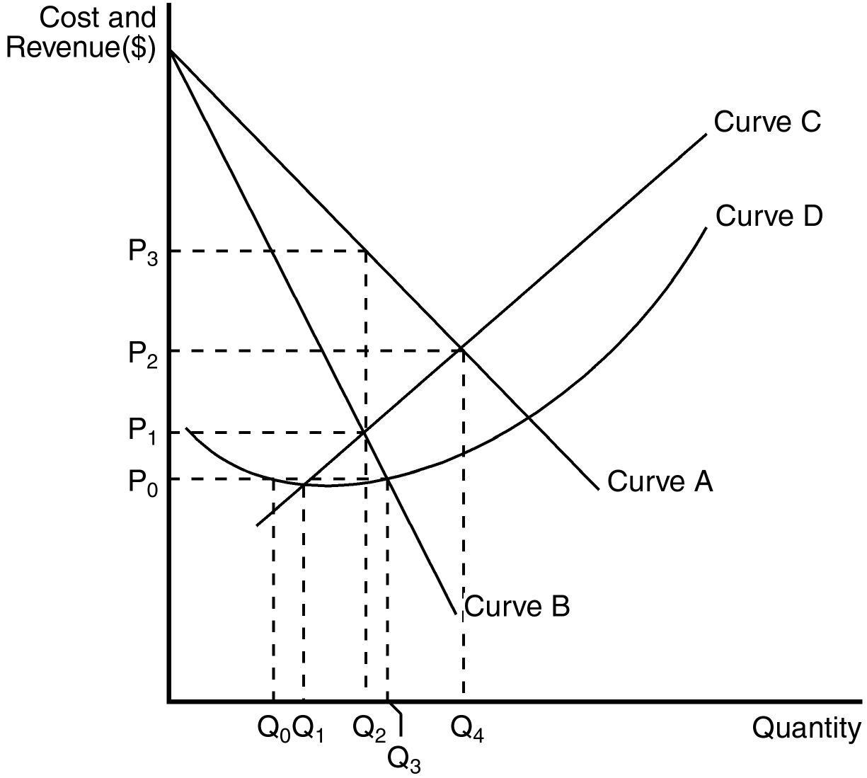

82. The demand curve for a monopoly firm is depicted by curve
a. A.
b. B.
c. C.
d. D.
ANSWER: a. A.
TYPE: M DIFFICULTY: 1 SECTION: 15.2
83. The marginal revenue curve for a monopoly firm is depicted by curve
a. A.
b. B.
c. C.
d. D.
ANSWER: b. B.
TYPE: M DIFFICULTY: 2 SECTION: 15.2
84. The marginal cost curve for a monopoly firm is depicted by curve
a. A.
b. B.
c. C.
d. D.
ANSWER: c. C.
TYPE: M DIFFICULTY: 2 SECTION: 15.2
85. The average total cost curve for a monopoly firm is depicted by curve
a. A.
b. B.
c. C.
d. D.
ANSWER: d. D.
TYPE: M DIFFICULTY: 2 SECTION: 15.2
86. If the monopoly firm is currently producing Q3 units of output, then a decrease in output will necessarily cause profit to
a. remain unchanged.
b. decrease.
c. increase as long as the new level of output is at least Q2.
d. increase as long as the new level of output is at least Q1.
ANSWER: c. increase as long as the new level of output is at least Q2.
TYPE: M DIFFICULTY: 2 SECTION: 15.2
87. Profit can always be increased by increasing the level of output by one unit if the monopolist is currently operating at
(i) Q0 .
(ii) Q1.
(iii) Q2.
(iv) Q3.
a. (i) or (ii)
b. (i), (ii) or (iii)
c. (iii) or (iv)
d (iv) only
ANSWER: a. (i) or (ii)
TYPE: M DIFFICULTY: 2 SECTION: 15.2
88. If the monopoly firm wants to maximize its profit, it should operate at a level of output equal to
a. Q1.
b. Q2.
c. Q3.
d. Q4.
ANSWER: b. Q2.
TYPE: M DIFFICULTY: 2 SECTION: 15.2
89. Profit will be maximized by charging a price equal to
a. P0.
b. P1.
c. P2.
d. P3.
ANSWER: d. P3.
TYPE: M DIFFICULTY: 2 SECTION: 15.2
90. Which of the following statements is true of a monopoly firm?
a. A monopoly firm is a price taker and has no supply curve.
b. A monopoly firm is a price maker and has no supply curve
c. A monopoly firm is a price maker and has a downward-sloping supply curve.
d. A monopoly firm is a price maker and has an upward-sloping supply curve.
ANSWER: b. A monopoly firm is a price maker and has no supply curve
TYPE: M DIFFICULTY: 2 SECTION: 15.2
91. Supply curves tell us how much producers are willing to supply at any given price. Hence, monopoly firms have
a. vertical supply curves.
b. steeper supply curves than competitive firms
c. flatter supply curves than competitive firms.
d. no supply curves.
ANSWER: d. no supply curves.
TYPE: M DIFFICULTY: 2 SECTION: 15.2
92. For a monopoly firm, the shape and position of the demand curve play a role in determining
(i) the profit-maximizing price.
(ii) the shape and position of the marginal cost curve.
(iii) the shape and position of the marginal revenue curve.
a. (i) and (ii)
b. (ii) and (iii)
c. (i) and (iii)
d. All of the above are correct.
ANSWER: c. (i) and (iii)
TYPE: M DIFFICULTY: 2 SECTION: 15.2
93. In a competitive market, a firm’s supply curve dictates the amount it will supply. In a monopoly market the
a. same is true.
b. supply curve conceptually makes sense, but in practice is never used.
c. supply curve will have limited predictive capacity.
d. decision about how much to supply is impossible to separate from the demand curve it faces.
ANSWER: d. decision about how much to supply is impossible to separate from the demand curve it faces.
TYPE: M DIFFICULTY: 2 SECTION: 15.2

The figure below reflects the cost and revenue structure for a monopoly firm. Use it to answer questions 94 through 98.

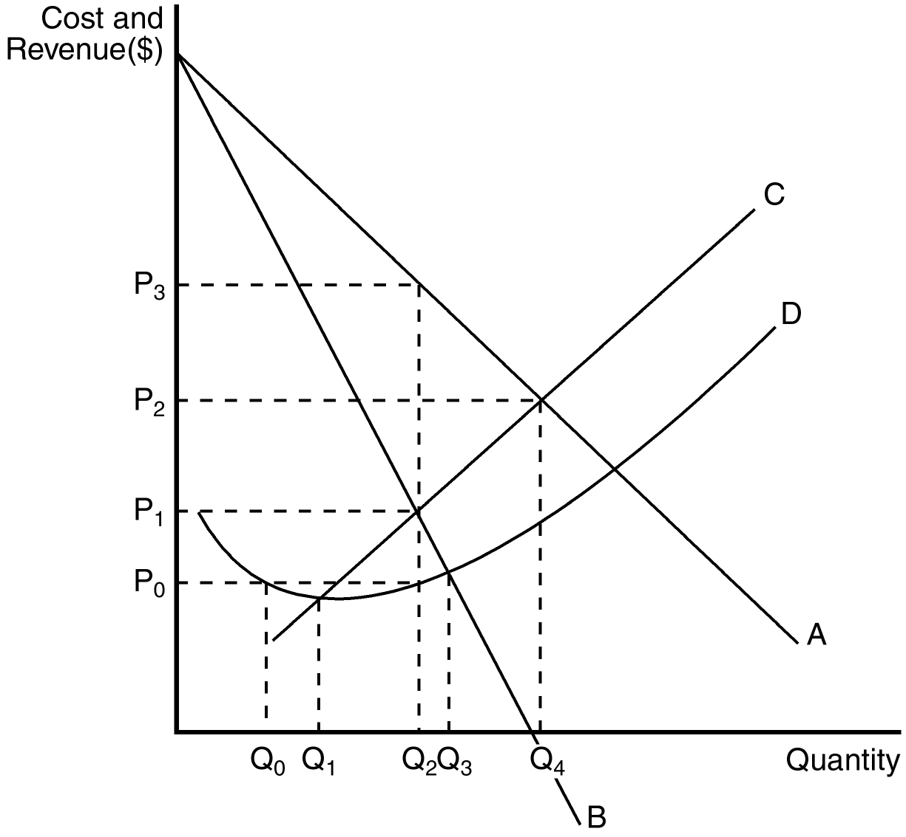

94. A profit-maximizing monopoly’s total revenue is equal to
a. P3 × Q2.
b. P2 × Q4.
c. (P3 – P0) × Q2.
d. (P3 – P0) × Q4.
ANSWER: a. P3 × Q2.
TYPE: M DIFFICULTY: 2 SECTION: 15.2
95. A profit-maximizing monopoly’s total cost is equal to
a. (P1 – P0) × Q2.
b. P0 × Q1.
c. P0 × Q2.
d. P0 × Q3.
ANSWER: c. P0 × Q2.
TYPE: M DIFFICULTY: 2 SECTION: 15.2
96. A profit-maximizing monopoly’s profit is equal to
a. P3 × Q2.
b. P2 × Q4.
c. (P3 – P0) × Q2.
d. (P3 – P0) × Q4.
ANSWER: c. (P3 – P0) × Q2.
TYPE: M DIFFICULTY: 2 SECTION: 15.2
97. Profit on a typical unit sold for a profit-maximizing monopoly would equal
a. P2 – P1.
b. P2 – P0.
c. P3 – P2.
d. P3 – P0.
ANSWER: d. P3 – P0.
TYPE: M DIFFICULTY: 2 SECTION: 15.2
98. At the profit-maximizing level of output,
a. marginal revenue is equal to P3.
b. marginal cost is equal to P3.
c. average revenue is equal to P3.
d. None of the above are correct.
ANSWER: c. average revenue is equal to P3.
TYPE: M DIFFICULTY: 2 SECTION: 15.2
99. When a pharmaceutical company discovers a new drug, patent law gives the monopoly
a. partial ownership of the right to sell the drug for a limited number of years.
b. partial ownership of the right to sell the drug for an unlimited number of years.
c. sole ownership of the right to sell the drug for a limited number of years.
d. sole ownership of the right to sell the drug for an unlimited number of years.
ANSWER: c. sole ownership of the right to sell the drug for a limited number of years.
TYPE: M DIFFICULTY: 1 SECTION: 15.2
100. Due to the nature of the patent laws on pharmaceuticals, the market for such drugs
a. always remains a competitive market.
b. always remains a monopolistic market.
c. switches from competitive to monopolistic once the firm’s patent runs out.
d. switches from monopolistic to competitive once the firm’s patent runs out.
ANSWER: d. switches from monopolistic to competitive once the firm’s patent runs out.
TYPE: M DIFFICULTY: 2 SECTION: 15.2
101. What happens to the price and quantity sold of a drug when its patent runs out?
(i) The price will fall.
(ii) The quantity sold will fall.
(iii) The marginal cost of producing the drug will rise.
a. (i) only
b. (i) and (ii)
c. (ii) and (iii)
d. All of the above are correct.
ANSWER: a. (i) only
TYPE: M DIFFICULTY: 2 SECTION: 15.2
102. Generic drugs enter the pharmaceutical drug market once
a. the ingredients to the name brand drug have been discovered.
b. 10 years have passed.
c. they are patented.
d. the patent on the name brand drug expires.
ANSWER: d. the patent on the name brand drug expires.
TYPE: M DIFFICULTY: 2 SECTION: 15.2
103. Name brand drugs are able to continue capitalizing on their market power even after generic drugs enter the market because
(i) almost all people fear the generic drug companies are devoting too few resources to research and development.
(ii) some people fear that generic drugs are inferior.
(iii) some people are loyal to the name brand.
a. (i) and (ii)
b. (ii) and (iii)
c. (i) and (iii)
d. All of the above are correct.
ANSWER: b. (ii) and (iii)
TYPE: M DIFFICULTY: 2 SECTION: 15.2
104. In a market characterized by monopoly, the market demand curve is
a. upward sloping.
b. horizontal.
c. downward sloping.
d. vertical.
ANSWER: c. downward sloping.
TYPE: M DIFFICULTY: 1 SECTION: 15.2
105. As a monopolist increases the quantity of output it sells, the price consumers are willing to pay for the good
a. is unaffected.
b. decreases.
c. increases.
d. There is not enough information given in answer the question.
ANSWER: b. decreases.
TYPE: M DIFFICULTY: 1 SECTION: 15.2
106. Competitive firms differ from monopolies in which of the following ways?
(i) Competitive firms do not have to worry about the price effect lowering their total revenue.
(ii) Marginal revenue for a competitive firm equals price, while marginal revenue for a monopoly is less than the price it is able to charge.
(iii) Monopolies must lower their price in order to sell more of their product, while competitive firms do not.
a. (i) and (ii)
b. (ii) and (iii)
c. (i) and (iii)
d. All of the above are correct.
ANSWER: d. All of the above are correct.
TYPE: M DIFFICULTY: 3 SECTION: 15.2
107. The monopolist's profit-maximizing quantity of output is determined by the intersection of which of the following two curves?
a. marginal cost and demand
b. marginal cost and marginal revenue
c. average total cost and marginal revenue
d. average variable cost and average revenue
ANSWER: b. marginal cost and marginal revenue
TYPE: M DIFFICULTY: 2 SECTION: 15.2
108. A monopolist is a price
a. taker, and therefore has no supply curve.
b. setter, and therefore has no demand curve.
c. setter, and therefore has no supply curve.
d. setter, and therefore has no variable cost curve.
ANSWER: c. setter, and therefore has no supply curve.
TYPE: M DIFFICULTY: 2 SECTION: 15.2
109. For a monopolist, profit is determined by which of the following equations?
a. Profit = Total Revenue – Total Cost
b. Profit = (Average Revenue – Average Total Cost) x Quantity
c. Profit = (Price – Average Total Cost) x Quantity
d. All of the above are correct.
ANSWER: d. All of the above are correct.
TYPE: M DIFFICULTY: 2 SECTION: 15.2
110. What is the monopolist's profit under the following conditions? The profit-maximizing price charged for goods produced is $16. The intersection of the marginal revenue and marginal cost curves occurs where output is 10 units and marginal cost is $8. Average total cost for 10 units of output is $6.
a. $20
b. $80
c. $100
d. $160
ANSWER: c. $100
TYPE: M DIFFICULTY: 2 SECTION: 15.2
111. What is the monopolist's profit under the following conditions? The profit-maximizing price charged for goods produced is $12. The intersection of the demand curve and the marginal cost curve occurs where output is 15 units and marginal cost is $6.
a. $90
b. $100
c. $180
d. Not enough information is given to determine the answer.
ANSWER: d. Not enough information is given to determine the answer.
TYPE: M DIFFICULTY: 2 SECTION: 15.2
112. A monopolist will choose to increase output when
a. market price increases.
b. at all levels of output, marginal cost increases.
c. at the present level of output, marginal revenue exceeds marginal cost.
d. All of the above are correct.
ANSWER: c. at the present level of output, marginal revenue exceeds marginal cost.
TYPE: M DIFFICULTY: 2 SECTION: 15.2
113. For a monopolist, when does marginal revenue exceed average revenue?
a. never
b. when output is less than the profit-maximizing level of output
c. when output is greater than the profit-maximizing level of output
d. when price is subject to the Law of Demand
ANSWER: a. never
TYPE: M DIFFICULTY: 2 SECTION: 15.2
114. If a monopolist sells 100 units at $8 per unit and realizes an average total cost of $6 per unit, what is the monopolist's profit?
a. $200
b. $400
c. $600
d. $800
ANSWER: a. $200
TYPE: M DIFFICULTY: 2 SECTION: 15.2
115. What is the monopolist's profit under the following conditions? The profit-maximizing price charged for goods produced is $12. The intersection of the marginal revenue and marginal cost curves occurs where output is 10 units, marginal cost is $8, and average total cost is $7.
a. Not enough information is given to determine the answer.
b. $10
c. $40
d. $50
ANSWER: d. $50
TYPE: M DIFFICULTY: 2 SECTION: 15.2
116. For a monopoly firm, the average revenue curve
a. starts at the same point on the vertical axis as the marginal revenue curve.
b. is downward sloping.
c. is the same as the demand curve.
d. All of the above are correct.
ANSWER: d. All of the above are correct.
TYPE: M DIFFICULTY: 2 SECTION: 15.2
117. Suppose a certain firm has a monopoly on electricity. To sell the 100th unit of electricity, the firm must experience
a. less marginal revenue on the 100th unit of electricity than it experienced on the 99th unit.
b. more average revenue on the 100th unit of electricity than it experienced on the 99th unit.
c. more total revenue on the 100 units of electricity than it experienced on the first 99 units.
d. All of the above are correct.
ANSWER: a. less marginal revenue on the 100th unit of electricity than it experienced on the 99th unit.
TYPE: M DIFFICULTY: 2 SECTION: 15.2
118. For a monopoly firm, the level of output at which marginal revenue equals zero is also the level of output at which
a. average revenue is zero.
b. profit is maximized.
c. total revenue is maximized.
d. marginal cost is zero.
ANSWER: c. total revenue is maximized.
TYPE: M DIFFICULTY: 3 SECTION: 15.2
119. Competitive firms and monopolists differ in which of the following ways?
a. A competitive firm cannot choose its level of output; a monopolist chooses its level of output.
b. A competitive firm’s short-run profit is always zero; a monopolist can have a positive short-run profit.
c. A competitive firm’s marginal revenue curve is horizontal; a monopolist’s marginal revenue curve is downward sloping.
d. All of the above are correct.
ANSWER: c. A competitive firm’s marginal revenue curve is horizontal; a monopolist’s marginal revenue curve is downward sloping.
TYPE: M DIFFICULTY: 2 SECTION: 15.2
120. For a monopolist,
a. average revenue is always greater than the price of the good.
b. marginal revenue is always less than the price of the good.
c. marginal cost is always greater than average total cost.
d. All of the above are correct.
ANSWER: b. marginal revenue is always less than the price of the good.
TYPE: M DIFFICULTY: 2 SECTION: 15.2
121. A monopolist’s profit-maximizing quantity of output is determined by the intersection of the
a. marginal revenue curve and the marginal cost curve.
b. marginal revenue curve and the average total cost curve.
c. demand curve and the marginal cost curve.
d. demand curve and the average total cost curve.
ANSWER: a. marginal revenue curve and the marginal cost curve.
TYPE: M DIFFICULTY: 2 SECTION: 15.2
122. The profit-maximization problem for a monopolist differs from that of a competitive firm in which of the following ways?
a. A competitive firm maximizes profit at the point where marginal revenue equals marginal cost; a monopolist maximizes profit at the point where marginal revenue exceeds marginal cost.
b. A competitive firm maximizes profit at the point where average revenue equals marginal cost; a monopolist maximizes profit at the point where average revenue exceeds marginal cost.
c. For a competitive firm, marginal revenue at the profit-maximizing level of output is equal to marginal revenue at all other levels of output; for a monopolist, marginal revenue at the profit-maximizing level of output is smaller than it is for larger levels of output.
d. For a profit-maximizing competitive firm, thinking at the margin is much more important than it is for a profit-maximizing monopolist.
ANSWER: b. A competitive firm maximizes profit at the point where average revenue equals marginal cost; a monopolist maximizes profit at the point where average revenue exceeds marginal cost.
TYPE: M DIFFICULTY: 3 SECTION: 15.2
123. Let P = price; MR = marginal revenue; and MC = marginal cost. For a profit-maximizing monopolist,
a. P = MR = MC.
b. P = MR < MC.
c. P = MR > MC.
d. P > MR = MC.
ANSWER: d. P > MR = MC.
TYPE: M DIFFICULTY: 2 SECTION: 15.2
124. When a monopoly increases its output and sales,
a. both the output effect and the price effect work to increase total revenue.
b. the output effect works to increase total revenue and the price effect works to decrease total revenue.
c. the output effect works to decrease total revenue and the price effect works to increase total revenue.
d. both the output effect and the price effect work to decrease total revenue.
ANSWER: b. the output effect works to increase total revenue and the price effect works to decrease total revenue.
TYPE: M DIFFICULTY: 2 SECTION: 15.2
125. For a monopoly, it is sometimes meaningful to consider negative values for
a. marginal revenue.
b. average revenue.
c. marginal cost.
d. average total cost.
ANSWER: a. marginal revenue.
TYPE: M DIFFICULTY: 2 SECTION: 15.2
126. A monopoly firm can sell 200 units of output for $36.00 per unit. Alternatively, it can sell 201 units of output for $35.80 per unit. The marginal revenue of the 201st unit of output is
a. $–35.80.
b. $–4.20.
c. $4.20.
d. $35.80.
ANSWER: b. $–4.20.
TYPE: M DIFFICULTY: 2 SECTION: 15.2
127. A monopoly firm can sell 150 units of output for $12.00 per unit. Alternatively, it can sell 151 units of output for $11.95 per unit. The marginal revenue of the 151st unit of output is
a. $–11.95.
b. $–4.45.
c. $4.45.
d. $11.95.
ANSWER: c. $4.45.
TYPE: M DIFFICULTY: 2 SECTION: 15.2

Refer to the information below to answer Questions 128 through 131.

A monopoly firm maximizes its profit by producing 500 units output (so Q = 500). At that level of output, its marginal revenue is $30, its average revenue is $40, and its average total cost is $34.
128. The firm’s profit-maximizing price is
a. $30.
b. between $30 and $34.
c. between $34 and $40.
d. $40.
ANSWER: d. $40.
TYPE: M DIFFICULTY: 2 SECTION: 15.2
129. At Q = 500, the firm’s total revenue is
a. $15,000.
b. $17,500.
c. $20,000.
d. $22,500.
ANSWER: c. $20,000.
TYPE: M DIFFICULTY: 2 SECTION: 15.2
130. The firm’s maximum profit is
a. $2,000.
b. $3,000.
c. $4,000.
d. $6,000.
ANSWER: b. $3,000.
TYPE: M DIFFICULTY: 2 SECTION: 15.2
131. At Q = 500, the firm’s marginal cost is
a. less than $30.
b. $30.
c. $34.
d. greater than $34.
ANSWER: b. $30.
TYPE: M DIFFICULTY: 2 SECTION: 15.2
132. A monopoly does not
a. have a supply curve.
b. have an average total cost curve.
c. choose the price for which it sells its output.
d. benefit from barriers to entry.
ANSWER: a. have a supply curve.
TYPE: M DIFFICULTY: 2 SECTION: 15.2
133. For a monopoly, the supply curve is a portion of its
a. marginal revenue curve.
b. marginal cost curve.
c. average total cost curve.
d. none of the above; a monopoly does not have a supply curve.
ANSWER: d. none of the above; a monopoly does not have a supply curve.
TYPE: M DIFFICULTY: 2 SECTION: 15.2
134. A monopolist faces the following demand curve:

Price Quantity Demanded
$51 1
$47 2
$42 3
$36 4
$29 5
$21 6
$12 7

The monopolist has total fixed costs of $60 and has a constant marginal cost of $15. What is the profit-maximizing level of production?
a. 2 units
b. 3 units
c. 4 units
d. 5 units
ANSWER: c. 4 units
TYPE: M DIFFICULTY: 3 SECTION: 15.2
135. A monopolist faces the following demand curve:

Price Quantity Demanded
$10 5
$9 10
$8 16
$7 23
$6 31
$5 49
$4 52
$3 60

The monopolist has total fixed costs of $40 and a constant marginal cost of $5. At the profit-maximizing level of output, the monopolist’s average total cost is
a. $9.00
b. $7.50
c. $6.74
d. $5.82
ANSWER: b. $7.50
TYPE: M DIFFICULTY: 3 SECTION: 15.2
136. A reduction in a monopolist’s fixed costs would
a. decrease the profit-maximizing price and increase the profit-maximizing quantity produced.
b. increase the profit-maximizing price and decrease the profit-maximizing quantity produced.
c. not effect the profit-maximizing price or quantity.
d. possibly increase, decrease or not effect profit-maximizing price and quantity, depending on the elasticity of demand.
ANSWER: c. not effect the profit-maximizing price or quantity.
TYPE: M DIFFICULTY: 3 SECTION: 15.2
137. A monopoly market
a. always maximizes total economic well-being.
b. always minimizes consumer surplus.
c. generally fails to maximize total economic well-being.
d. generally fails to maximize producer surplus.
ANSWER: c. generally fails to maximize total economic well-being.
TYPE: M DIFFICULTY: 2 SECTION: 15.3
138. For a profit-maximizing monopolist, output should be increased to enhance economic well-being as long as
a. average revenue exceeds marginal cost.
b. average revenue exceeds average total cost.
c. marginal revenue exceeds marginal cost.
d. marginal revenue exceeds average total cost.
ANSWER: a. average revenue exceeds marginal cost.
TYPE: M DIFFICULTY: 2 SECTION: 15.3
139. The economic inefficiency of a monopolist can be measured by the
a. number of consumers who are unable to purchase the product because of its high price.
b. excess profit generated by monopoly firms.
c. poor quality of service offered by monopoly firms.
d. deadweight loss.
ANSWER: d. deadweight loss.
TYPE: M DIFFICULTY: 2 SECTION: 15.3
140. The problem with monopolies is their ability
(i) to do away with barriers to entry.
(ii) to price their product at a level that exceeds marginal cost.
(iii) to restrict output below the socially efficient level of production.
a. (i) and (iii)
b. (ii) and (iii)
c. (iii) only
d. All of the above are correct.
ANSWER: b. (ii) and (iii)
TYPE: M DIFFICULTY: 2 SECTION: 15.3
141. The socially efficient level of production occurs where the marginal cost curve intersects which of the following curves?
a. average variable cost
b. average total cost
c. demand
d. marginal revenue
ANSWER: c. demand
TYPE: M DIFFICULTY: 2 SECTION: 15.3
142. Monopoly pricing prevents some mutually beneficial trades from taking place. These unrealized mutually beneficial trades are
a. of little concern to society.
b. a deadweight loss to society.
c. a sunk cost to society.
d. also observed in competitive markets.
ANSWER: b. a deadweight loss to society.
TYPE: M DIFFICULTY: 2 SECTION: 15.3
143. The difference in total surplus between a socially efficient level of production and a monopolist's level of production is
a. offset by regulatory revenues.
b. called a deadweight loss.
c. usually small and insignificant.
d. All of the above are correct.
ANSWER: b. called a deadweight loss.
TYPE: M DIFFICULTY: 2 SECTION: 15.3
144. Consider a profit-maximizing monopoly pricing under the following conditions: The profit-maximizing price charged for goods produced is $16.The intersection of the marginal revenue and marginal cost curves occurs where output is 10 units and marginal cost is $8. The socially efficient level of production is 12 units. The demand curve and marginal cost curves are linear. What is the deadweight loss?
a. $4
b. $8
c. $16
d. $64
ANSWER: b. $8
TYPE: M DIFFICULTY: 4 SECTION: 15.3
145. Economic well-being is generally measured by
(i) total surplus.
(ii) the sum of consumer surplus and producer surplus.
(iii) marginal revenue to the producer minus the average cost to the consumer.
a. (i) and (ii)
b. (ii) and (iii)
c. (i) and (iii)
d. (ii) only
ANSWER: a. (i) and (ii)
TYPE: M DIFFICULTY: 2 SECTION: 15.3
146. Consumers’ willingness to pay for a good minus the amount they actually pay for it equals
a. consumer surplus.
b. consumer benefit.
c. price discriminant.
d. quantity demanded.
ANSWER: a. consumer surplus.
TYPE: M DIFFICULTY: 2 SECTION: 15.3
147. The amount that producers receive for a good minus their costs of producing it equals
a. quantity supplied.
b. supply price.
c. producer gain.
d. producer surplus.
ANSWER: d. producer surplus.
TYPE: M DIFFICULTY: 2 SECTION: 15.3
148. For a monopoly market, total surplus can be defined as the value of the good to
a. producers minus the cost incurred by consumers.
b. producers plus the cost incurred by consumers.
c. consumers minus the costs of producing the good.
d. consumers plus the cost of producing the good.
ANSWER: c. consumers minus the costs of producing the good.
TYPE: M DIFFICULTY: 2 SECTION: 15.3

The figure below depicts the demand and marginal cost curves of a profit-maximizing monopolist. Use the figure to answer questions 149 and 150.

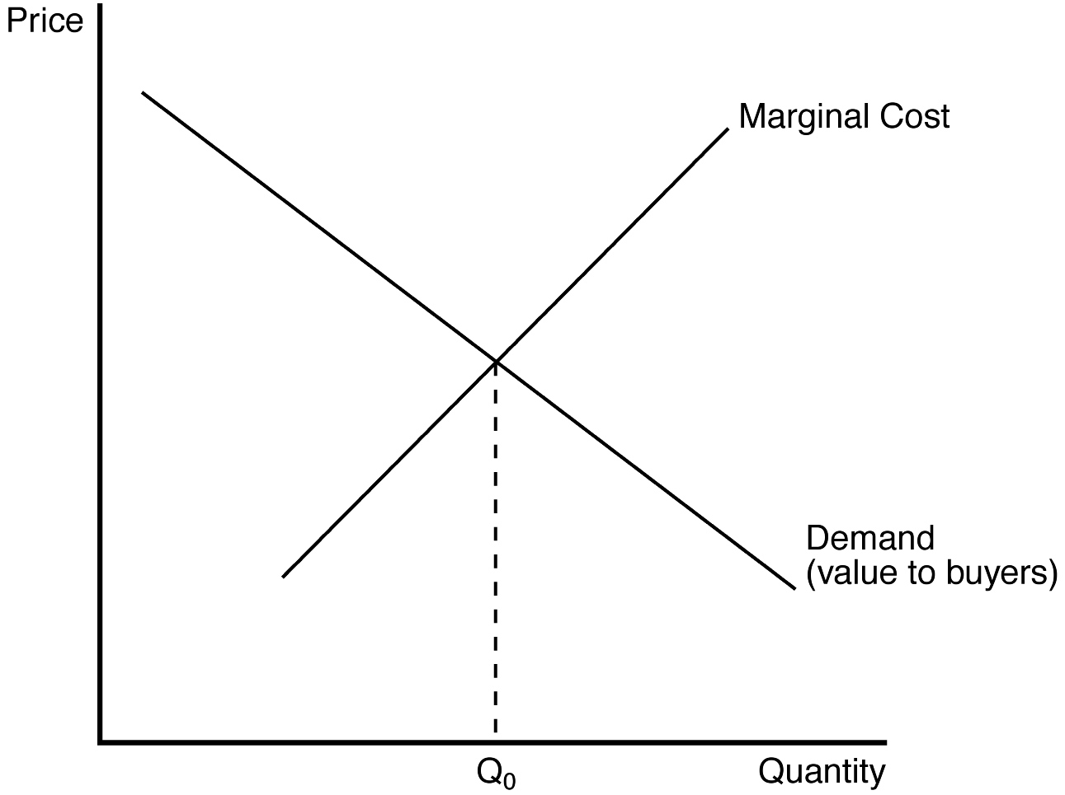
149. A benevolent social planner would cause the monopoly firm to operate at an output level
a. below Q0.
b. above Q0.
c. equal to Q0.
d. equal to zero.
ANSWER: c. equal to Q0.
TYPE: M DIFFICULTY: 2 SECTION: 15.3
150. If the monopoly operates at an output level below Q0, then an increase in output toward Q0 (but not so large an increase as to exceed Q0) would
a. raise the price and raise total surplus.
b. lower the price and raise total surplus.
c. raise the price and lower total surplus.
d. lower the price and lower total surplus.
ANSWER: b. lower the price and raise total surplus.
TYPE: M DIFFICULTY: 2 SECTION: 15.3
151. Selling a good at a price determined by the intersection of the demand curve and the marginal cost curve is consistent with
(i) the socially-optimal level of output.
(ii) the market solution for profit-maximizing competitive firms.
(iii) the market solution for a profit-maximizing monopoly firm.
a. (i) and (ii)
b. (ii) and (iii)
c. (i) and (iii)
d. All of the above are correct.
ANSWER: a. (i) and (ii)
TYPE: M DIFFICULTY: 2 SECTION: 15.3
152. A monopoly firm chooses to supply the market with a quantity of their goods that is determined by the intersection of the
a. marginal cost and demand curves .
b. average total cost and demand curves.
c. marginal revenue and average total cost curves.
d. marginal revenue and marginal cost curves.
ANSWER: d. marginal revenue and marginal cost curves.
TYPE: M DIFFICULTY: 2 SECTION: 15.3
153. If a monopoly sells a quantity of its good that is smaller than the socially-optimal level, the price will be
a. socially efficient.
b. inefficiently low.
c. inefficiently high.
d. inefficiently low or inefficiently high; either case can prevail.
ANSWER: c. inefficiently high.
TYPE: M DIFFICULTY: 2 SECTION: 15.3
154. Inefficiency arises from a monopoly because
a. the monopoly firm earns an excessively large profit.
b. some buyers will refrain from buying the good, due to the high price.
c. consumers who buy the goods feel exploited.
d. All of the above are correct.
ANSWER: b. some buyers will refrain from buying the good, due to the high price.
TYPE: M DIFFICULTY: 2 SECTION: 15.3

The figure below depicts the demand, marginal revenue and marginal cost curves of a profit-maximizing monopolist. Use the figure to answer questions 155 and 156.

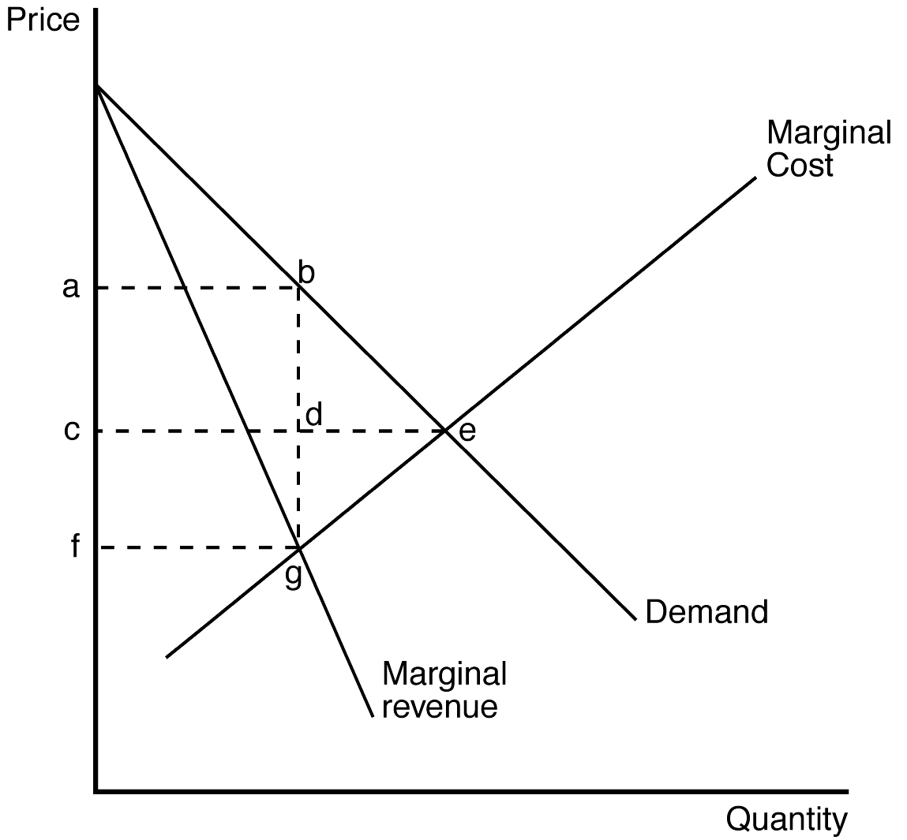
155. Which of the following areas represents the deadweight loss due to monopoly pricing?
a. triangle bde
b. triangle bge
c. rectangle acdb
d. rectangle cfgd
ANSWER: b. triangle bge
TYPE: M DIFFICULTY: 2 SECTION: 15.3
156. Total surplus lost due to monopoly pricing is reflected in
a. triangle bde.
b. triangle bge.
c. rectangle acdb.
d. rectangle cfgd.
ANSWER: b. triangle bge.
TYPE: M DIFFICULTY: 2 SECTION: 15.3
157. Monopoly firms exert their market power by charging a price that is
a. above average revenue.
b. below average total cost.
c. above marginal cost.
d. below marginal cost.
ANSWER: c. above marginal cost.
TYPE: M DIFFICULTY: 2 SECTION: 15.3
158. In comparison to the price a competitive firm charges, monopoly pricing has the effect of causing
a. the level of output to be higher.
b. the price of output to be higher.
c. consumer surplus to be larger.
d. All of the above are correct.
ANSWER: b. the price of output to be higher.
TYPE: M DIFFICULTY: 2 SECTION: 15.3
159. Total economic loss due to monopoly pricing is equal to the
a. deadweight loss.
b. loss to consumer and producer surplus combined.
c. loss to total surplus.
d. All of the above are correct.
ANSWER: d. All of the above are correct.
TYPE: M DIFFICULTY: 2 SECTION: 15.3
160. The inefficiency of a deadweight loss stems from the fact that
a. high monopoly prices take money from consumers’ pockets and put it in the pocket of the monopoly owners.
b. consumers who still buy the product at the high price are worse off than they would be if they paid a lower price.
c. consumers buy fewer units due to the monopoly price, which exceeds the socially-optimal price.
d. All of the above are correct.
ANSWER: c. consumers buy fewer units due to the monopoly price, which exceeds the socially-optimal price.
TYPE: M DIFFICULTY: 2 SECTION: 15.3
161. When the government creates a monopoly, the social loss may include
a. falling marginal cost.
b. the cost of lawyers and lobbyists to convince lawmakers to continue its monopoly.
c. high monopoly profits.
d. All of the above are correct.
ANSWER: b. the cost of lawyers and lobbyists to convince lawmakers to continue its monopoly.
TYPE: M DIFFICULTY: 2 SECTION: 15.3
162. If a social planner were running a monopoly, that planner could achieve an efficient outcome by charging the price that is determined by the
a. minimum point on the average total cost curve.
b. intersection of the average total cost curve and the demand curve.
c. intersection of the marginal cost curve and the demand curve.
d. intersection of the marginal cost curve and the marginal revenue curve.
ANSWER: c. intersection of the marginal cost curve and the demand curve.
TYPE: M DIFFICULTY: 2 SECTION: 15.3
163. The deadweight loss that arises in monopoly is a consequence of the fact that the monopoly
a. price is higher than the price that would achieve efficiency.
b. price exceeds marginal cost.
c. output is lower than the level of output that would achieve efficiency.
d. All of the above are correct.
ANSWER: d. All of the above are correct.
TYPE: M DIFFICULTY: 2 SECTION: 15.3
164. Which of the following statements is correct?
a. The benefits that accrue to a monopoly firm’s owners are equal to the costs that are incurred by consumers of that firm’s product.
b. The deadweight loss that arises in monopoly stems from the fact that the profit-maximizing monopoly firm produces a quantity of output that exceeds the socially-efficient quantity.
c. The deadweight loss caused by monopoly is similar to the deadweight loss caused by a tax on a product.
d. The main social problem caused by monopoly is monopoly profit.
ANSWER: c. The deadweight loss caused by monopoly is similar to the deadweight loss caused by a tax on a product.
TYPE: M DIFFICULTY: 3 SECTION: 15.3
165. The social problem caused by monopoly is
a. an inefficiently low quantity of output.
b. an inefficiently high value of marginal cost.
c. excessive monopoly profits.
d. excessive producer surplus.
ANSWER: a. an inefficiently low quantity of output.
TYPE: M DIFFICULTY: 2 SECTION: 15.3

Refer to the diagram below to answer Questions 166 through 169.

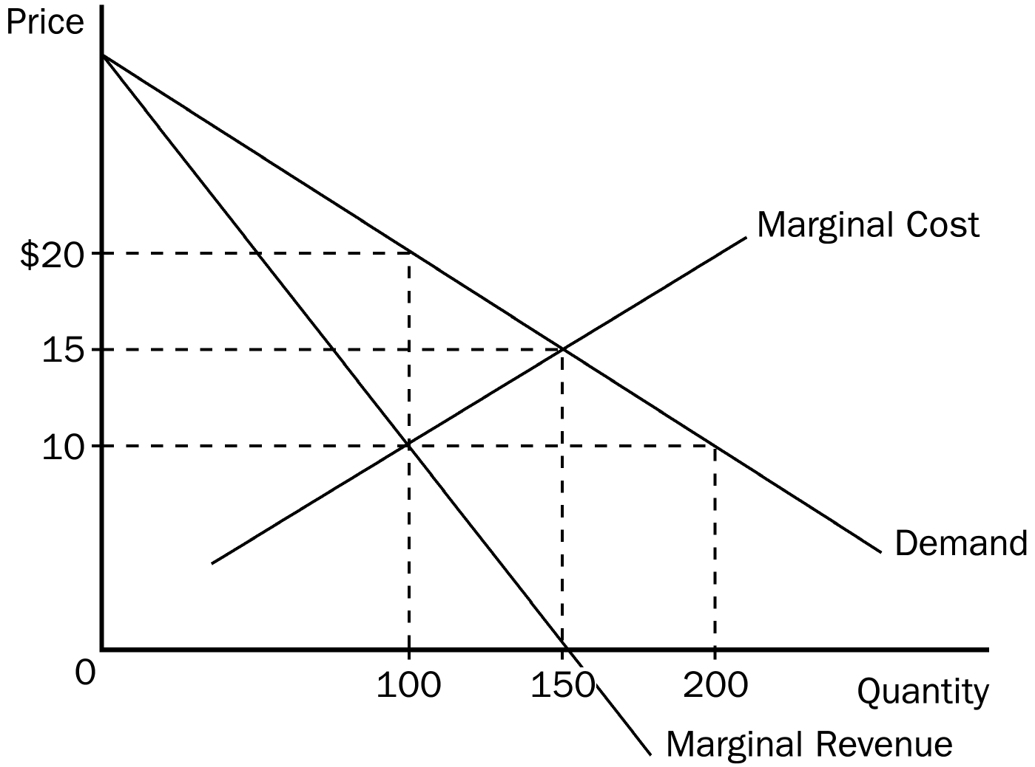

166. To maximize total surplus, a benevolent social planner would choose which of the following outcomes?
a. 100 units of output and a price of $10 per unit
b. 150 units of output and a price of $10 per unit
c. 150 units of output and a price of $15 per unit
d. 200 units of output and a price of $10 per unit
ANSWER: c. 150 units of output and a price of $15 per unit
TYPE: M DIFFICULTY: 2 SECTION: 15.3
167. To maximize its profit, a monopolist would choose which of the following outcomes?
a. 100 units of output and a price of $10 per unit
b. 100 units of output and a price of $20 per unit
c. 150 units of output and a price of $15 per unit
d. 200 units of output and a price of $20 per unit
ANSWER: b. 100 units of output and a price of $20 per unit
TYPE: M DIFFICULTY: 2 SECTION: 15.3
168. The monopolist’s maximum profit
a. is $800.
b. is $1,000.
c. is $1,250.
d. cannot be determined from the diagram.
ANSWER: d. cannot be determined from the diagram.
TYPE: M DIFFICULTY: 2 SECTION: 15.3
169. The deadweight loss caused by a profit-maximizing monopoly amounts to
a. $150.
b. $200.
c. $250.
d. $300.
ANSWER: c. $250.
TYPE: M DIFFICULTY: 3 SECTION: 15.3
170. One method used to control the ability of firms to capture monopoly profit in the United States is through
a. government purchase of products produced by monopolists.
b. government distribution of a monopolist's excess production.
c. enforcement of antitrust laws.
d. regulation of firms in highly competitive markets.
ANSWER: c. enforcement of antitrust laws.
TYPE: M DIFFICULTY: 2 SECTION: 15.4
171. Antitrust laws may
a. enhance the ability of firms to capture profits from a concentration of market power.
b. enhance the ability of firms to reduce economic losses.
c. restrict the ability of firms to operate at the socially efficient level of production.
d. restrict the ability of firms to merge.
ANSWER: d. restrict the ability of firms to merge.
TYPE: M DIFFICULTY: 2 SECTION: 15.4
172. One problem with government regulation of monopolies is that
a. a benevolent government is likely to be interested in generating profits for political gain.
b. regulated industries typically have rising average costs.
c. the government typically has little incentive to reduce costs.
d. a government-regulated outcome will increase the profitability of the monopoly.
ANSWER: c. the government typically has little incentive to reduce costs.
TYPE: M DIFFICULTY: 2 SECTION: 15.4
173. For a typical natural monopoly, average total cost is
a. falling and marginal cost is above average total cost.
b. falling and marginal cost is below average total cost.
c. rising and marginal cost is below average total cost.
d. rising and marginal cost is above average total cost.
ANSWER: b. falling and marginal cost is below average total cost.
TYPE: M DIFFICULTY: 2 SECTION: 15.4
174. One problem with regulating a monopolist on the basis of cost is that
a. regulators are unable to effectively control prices and/or production.
b. it does not provide an incentive for the monopolist to reduce its cost.
c. a monopolist's costs, by definition, are higher than costs of perfectly competitive firms.
d. a monopolist is still able to generate excessive economic profits.
ANSWER: b. it does not provide an incentive for the monopolist to reduce its cost.
TYPE: M DIFFICULTY: 2 SECTION: 15.4
175. When regulators use a marginal cost pricing strategy to regulate a natural monopoly, the regulated monopoly
a. will experience a loss.
b. will experience a price below average total cost.
c. may rely on a government subsidy to remain in business.
d. All of the above are correct.
ANSWER: d. All of the above are correct.
TYPE: M DIFFICULTY: 2 SECTION: 15.4
176. The key issue in determining the efficiency of public versus private ownership of a monopoly is
a. the tendency for efficient management of publicly owned enterprises.
b. the inability of private monopolies to get rid of managers that are doing a bad job.
c. the propensity of private monopolies to generate excessive profits.
d. how ownership of the firm affects the cost of production.
ANSWER: d. how ownership of the firm affects the cost of production.
TYPE: M DIFFICULTY: 2 SECTION: 15.4
177. The collection of statutes aimed at curbing monopoly power is called
a. the 14th amendment.
b. the Clayton Act.
c. the Sherman Act.
d. antitrust law.
ANSWER: d. antitrust law.
TYPE: M DIFFICULTY: 2 SECTION: 15.4
178. The legislation passed by Congress in 1890 to reduce the market power of large and powerful "trusts" is called the
a. Morgan Act.
b. Sherman Act.
c. Clayton Act.
d. 14th Amendment.
ANSWER: b. Sherman Act.
TYPE: M DIFFICULTY: 2 SECTION: 15.4
179. Antitrust laws allow the government to
a. prevent mergers.
b. break up companies.
c. promote competition.
d. All of the above are correct.
ANSWER: d. All of the above are correct.
TYPE: M DIFFICULTY: 2 SECTION: 15.4
180. Since natural monopolies have a declining average cost curve, regulating natural monopolies by setting price equal to marginal cost would
a. cause the monopolist to operate at a loss.
b. result in a less than optimal total surplus.
c. maximize producer surplus.
d. All of the above are correct.
ANSWER: a. cause the monopolist to operate at a loss.
TYPE: M DIFFICULTY: 2 SECTION: 15.4
181. The debate concerning the tradeoffs between "market failure" and "political failure" in the American economy provides support for which of the following solutions to the problems of monopolies?
a. public ownership of monopolies
b. government regulation of monopolies
c. government incentives to promote competition in monopolized industries
d. doing nothing at all
ANSWER: d. doing nothing at all
TYPE: M DIFFICULTY: 2 SECTION: 15.4
182. In order for antitrust laws to raise social welfare, the government must
a. disallow synergy benefits from accruing to monopolists.
b. disallow any mergers from taking place.
c. be able to determine which mergers are desirable and which are not.
d. always attempt to keep markets in their most competitive form.
ANSWER: c. be able to determine which mergers are desirable and which are not.
TYPE: M DIFFICULTY: 2 SECTION: 15.4
183. Reduced competition through merging of companies will raise social welfare
a. if the cost from the synergies exceeds the benefit of increased market power.
b. if the benefit from the synergies exceeds the social cost of increased market power.
c. Always.
d. Never.
ANSWER: b. if the benefit from the synergies exceeds the social cost of increased market power.
TYPE: M DIFFICULTY: 2 SECTION: 15.4
184. In the United States, in the majority of cases where there is a natural monopoly, the government usually deals with the problem
a. by splitting the natural monopoly into smaller companies.
b. through regulation.
c. by turning the natural monopoly into a public enterprise.
d. All of the above are correct.
ANSWER: b. through regulation.
TYPE: M DIFFICULTY: 2 SECTION: 15.4
185. When regulating a natural monopoly, one of the problems with setting price equal to average cost is that
a. there is no incentive for the monopolist to lower its costs.
b. consumer surplus is not maximized.
c. total surplus is not optimized.
d. All of the above are correct.
ANSWER: d. All of the above are correct.
TYPE: M DIFFICULTY: 2 SECTION: 15.4
186. Private ownership of a monopoly may benefit society because the monopoly will have an incentive to
a. charge a price that is consistent with that of a benevolent social planner.
b. charge a price that prevents some people from buying.
c. price its good according to the intersection of marginal cost and average revenue.
d. lower its costs so that it can earn more profit.
ANSWER: d. lower its costs so that it can earn more profit.
TYPE: M DIFFICULTY: 2 SECTION: 15.4
187. Government-run monopolies may lead to undesirable outcomes in the form of
a. special interest groups that attempt to block cost reductions.
b. customers and taxpayer losses when the monopoly operates inefficiently.
c. the political system as the only form of recourse for customers.
d. All of the above are correct.
ANSWER: d. All of the above are correct.
TYPE: M DIFFICULTY: 2 SECTION: 15.4
188. Policymakers are discussing various proposals regarding how to deal with natural monopolies. Senator Huff wants to regulate natural monopolies by equating price with average total cost. Huff contends that such a policy will ensure that monopolies make every effort to reduce costs. Senator Puff wants the government to own natural monopolies. Puff argues that government-owned monopolies usually do a better job of holding down costs than privately owned monopolies. Which senator’s argument is correct?
a. Senator Huff
b. Senator Puff
c. both Senators
d. neither Senator
ANSWER: d. Neither Senator
TYPE: M DIFFICULTY: 2 SECTION: 15.4
189. Which of the following is the most likely reason the city council in New York City consistently denies licenses to independent van drivers selling rides to the public?
a. Allowing the vans to operate would reduce social welfare.
b. The van drivers engage in price discrimination.
c. Allowing the vans to operate would allow them to unfairly take advantage of poor residents.
d. The vans are a threat to the public transit monopoly, which makes campaign contributions to the city council members.
ANSWER: d. The vans are a threat to the public transit monopoly, which makes campaign contributions to the city council members.
TYPE: M DIFFICULTY: 2 SECTION: 15.4
190. In a natural monopoly,
a. society would be better off if anti-trust laws were used to create many different firms in the market.
b. the marginal cost curve is positively sloped.
c. if the government requires marginal cost pricing, it must pay the monopolist a subsidy.
d. the marginal revenue curve is horizontal.
ANSWER: c. if the government requires marginal cost pricing, it must pay the monopolist a subsidy.
TYPE: M DIFFICULTY: 2 SECTION: 15.4
191. A perfectly price-discriminating monopolist is able to
a. maximize profit and produce a socially-optimal level of output.
b. maximize profit, but not produce a socially-optimal level of output.
c. produce a socially-optimal level of output, but not maximize profit.
d. exercise illegal preferences regarding the race and/or gender of its employees.
ANSWER: a. maximize profit and produce a socially-optimal level of output.
TYPE: M DIFFICULTY: 2 SECTION: 15.5
192. When a monopolist is able to sell its product at different prices, it is engaging in
a. distribution pricing.
b. quality adjusted pricing.
c. price differentiation.
d. price discrimination.
ANSWER: d. price discrimination.
TYPE: M DIFFICULTY: 1 SECTION: 15.5
Use the following information to answer questions 193 through 195.

Black Box Cable TV is able to purchase an exclusive right to sell a premium movie channel (PMC) in its market area. Let's assume that Black Box Cable pays $150,000 a year for the exclusive marketing rights to PMC. Since Black Box has already installed cable to all of the homes in its market area, the marginal cost of PMC to subscribers is zero. The manager of Black Box needs to know what price to charge for the PMC service to maximize her profit. Before setting price, she hires an economist to estimate demand for the PMC service. The economist discovers that there are two types of subscribers who value premium movie channels. First are the 4,000 die-hard TV viewers who will pay as much as $150 a year for the new PMC premium channel. Second, the PMC channel will appeal to about 20,000 occasional TV viewers who will pay as much as $20 a year for a subscription to PMC.
193. If Black Box Cable TV is unable to price discriminate, what price will it choose to maximize its profit and what is the amount of the profit?
a. price = $20; profit = $400,000
b. price = $20; profit = $330,000
c. price = $150; profit = $450,000
d. price = $150; profit = $600,000
ANSWER: c. price = $150; profit = $450,000
TYPE: M DIFFICULTY: 2 SECTION: 15.5
194. If Black Box Cable TV is able to price discriminate, what would be the maximum amount of profit it could generate?
a. $500,000
b. $600,000
c. $850,000
d. $925,000
ANSWER: c. $850,000
TYPE: M DIFFICULTY: 2 SECTION: 15.5
195. What is the deadweight loss associated with the nondiscriminating pricing policy compared to the price discriminating policy?
a. $375,000
b. $400,000
c. $475,000
d. It cannot be determined from the information provided.
ANSWER: b. $400,000
TYPE: M DIFFICULTY: 2 SECTION: 15.5
196. Price discrimination is a rational strategy for a profit-maximizing monopolist when
a. the monopolist finds itself able to produce only limited amounts of output.
b. consumers are unable to be segmented into identifiable markets.
c. the monopolist wishes to increase the deadweight loss that results from profit-maximizing behavior.
d. there is no opportunity for arbitrage across market segmentations.
ANSWER: d. there is no opportunity for arbitrage across market segmentations.
TYPE: M DIFFICULTY: 2 SECTION: 15.5
197. If a monopolist is able to perfectly price discriminate,
a. consumer surplus is always increased.
b. total surplus is always decreased.
c. consumer surplus and deadweight losses are transformed into monopoly profits.
d. the price effect dominates the output effect on monopoly revenue.
ANSWER: c. consumer surplus and deadweight losses are transformed into monopoly profits.
TYPE: M DIFFICULTY: 2 SECTION: 15.5
198. The practice of selling the same goods to different customers at different prices, but with the same marginal cost, is known as
a. price segregation.
b. price discrimination.
c. arbitrage.
d. monopoly pricing.
ANSWER: b. price discrimination.
TYPE: M DIFFICULTY: 2 SECTION: 15.5
199. In theory, perfect price discrimination
a. decreases the monopolist's profits.
b. decreases consumer surplus.
c. increases deadweight loss.
d. All of the above are correct.
ANSWER: b. decreases consumer surplus.
TYPE: M DIFFICULTY: 2 SECTION: 15.5
200. For a firm to price discriminate, it must
a. be a natural monopoly.
b. be regulated by the government.
c. have some market power.
d. None of the above are correct.
ANSWER: c. have some market power.
TYPE: M DIFFICULTY: 2 SECTION: 15.5
201. A rational pricing strategy for a profit-maximizing monopolist is
a. price discrimination.
b. price segregation.
c. synergy pricing.
d. average cost pricing.
ANSWER: a. price discrimination.
TYPE: M DIFFICULTY: 2 SECTION: 15.5
202. Price discrimination requires the firm to
a. separate customers according to their willingness to pay.
b. differentiate between different units of its product.
c. engage in arbitrage.
d. All of the above are correct.
ANSWER: a. separate customers according to their willingness to pay.
TYPE: M DIFFICULTY: 2 SECTION: 15.5
203. When deciding what price to charge consumers, the monopolist may choose to charge them different prices based on the customers'
a. geographical location.
b. age.
c. income.
d. All of the above are correct.
ANSWER: d. All of the above are correct.
TYPE: M DIFFICULTY: 2 SECTION: 15.5
204. A market force that can prevent firms from price discriminating is
a. fluctuating resource prices.
b. arbitrage.
c. high fixed costs.
d. All of the above are correct.
ANSWER: b. arbitrage.
TYPE: M DIFFICULTY: 2 SECTION: 15.5
205. Which of the following can eliminate the inefficiency inherent in monopoly pricing?
a. arbitrage
b. cost-plus pricing
c. price discrimination
d. regulations that force monopolies to reduce their levels of output
ANSWER: c. price discrimination
TYPE: M DIFFICULTY: 2 SECTION: 15.5
206. A firm cannot price discriminate if it
a. has perfect information about consumer demand.
b. operates in a competitive market
c. faces a downward-sloping demand curve.
d. is regulated by the government.
ANSWER: b. operates in a competitive market
TYPE: M DIFFICULTY: 2 SECTION: 15.5
207. A firm cannot price discriminate if
a. its marginal revenue is constant for all levels of output.
b. it operates in a competitive market.
c. it cannot group buyers according to their willingness to pay.
d. All of the above are correct.
ANSWER: b. it operates in a competitive market.
TYPE: M DIFFICULTY: 2 SECTION: 15.5
208. The process of buying a good in one market at a low cost and selling the good in another market for a higher cost in order to profit from the price difference is known as
a. sabotage.
b. conspiracy.
c. arbitrage.
d. collusion.
ANSWER: c. arbitrage.
TYPE: M DIFFICULTY: 1 SECTION: 15.5
209. Which of the following may eliminate some or all of the inefficiency that results from monopoly pricing?
a. The government can regulate the monopoly.
b. The monopoly can be prohibited from price discriminating.
c. The monopoly can be forced to operate at a point where its marginal revenue is equal to its marginal cost.
d. All of the above are correct.
ANSWER: a. The government can regulate the monopoly.
TYPE: M DIFFICULTY: 2 SECTION: 15.5
210. Price discrimination adds to social welfare in the form of
(i) increased total surplus.
(ii) increased profits to the monopolist.
(iii) increased consumer surplus.
a. (i) and (ii)
b. (ii) and (iii)
c. (i) and (iii)
d. All of the above are correct.
ANSWER: a. (i) and (ii)
TYPE: M DIFFICULTY: 2 SECTION: 15.5
211. Perfect price discrimination describes a situation in which the monopolist
a. knows the exact willingness to pay of each of its customers.
b. charges exactly two different prices to exactly two different groups of customers.
c. maximizes consumer surplus.
d. experiences a zero economic profit.
ANSWER: a. knows the exact willingness to pay of each of its customers.
TYPE: M DIFFICULTY: 2 SECTION: 15.5

The figure below depicts the demand, marginal revenue and marginal cost curves of a profit-maximizing monopolist. Use the figure to answer questions 212 through 217.

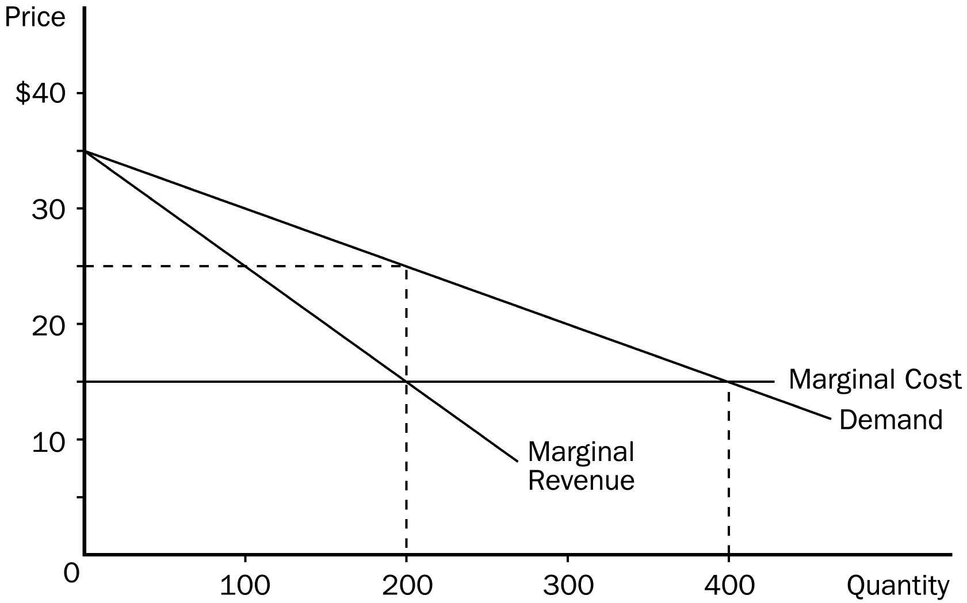

212. If the monopoly firm is NOT allowed to price discriminate, then consumer surplus amounts to
a. $0.
b. $500.
c. $1,000.
d. $2,000.
ANSWER: c. $1,000.
TYPE: M DIFFICULTY: 3 SECTION: 15.5
213. If the monopoly firm perfectly price discriminates, then consumer surplus amounts to
a. $0.
b. $250.
c. $500.
d. $1,000.
ANSWER: a. $0.
TYPE: M DIFFICULTY: 3 SECTION: 15.5
214. If the monopoly firm is NOT allowed to price discriminate, then the deadweight loss amounts to
a. $50.
b. $100.
c. $500.
d. $1,000.
ANSWER: d. $1,000.
TYPE: M DIFFICULTY: 3 SECTION: 15.5
215. If the monopoly firm perfectly price discriminates, then the deadweight loss amounts to
a. $0.
b. $100.
c. $200.
d. $500.
ANSWER: a. $0.
TYPE: M DIFFICULTY: 3 SECTION: 15.5
216. Monopoly profit without price discrimination equals
a. $500.
b. $1,000.
c. $2,000.
d. $4,000.
ANSWER: c. $2,000.
TYPE: M DIFFICULTY: 2 SECTION: 15.5
217. Monopoly profit with perfect price discrimination equals
a. $500.
b. $1,000.
c. $2,000.
d. $4,000.
ANSWER: d. $4,000.
TYPE: M DIFFICULTY: 2 SECTION: 15.5
218. In reality, perfect price discrimination is
a. used by about 75 percent of all monopolies.
b. used by about 50 percent of all monopolies.
c. seldom used by monopolies because it leads to lower profits.
d. not possible.
ANSWER: d. not possible.
TYPE: M DIFFICULTY: 2 SECTION: 15.5
219. Compared to the monopoly outcome with a single price, imperfect price discrimination
(i) sometimes raises economic welfare.
(ii) sometimes lowers economic welfare.
(iii) always leads to a lower quantity of output.
a. (i) and (ii)
b. (ii) and (iii)
c. (i) and (iii)
d. Any of these outcomes is possible.
ANSWER: a. (i) and (ii)
TYPE: M DIFFICULTY: 2 SECTION: 15.5
220. Many movie theaters allow discount tickets to be sold to senior citizens because
a. senior-citizen laws mandate such discounts.
b. efforts of goodwill show community respect and win loyal patrons.
c. the theaters are profit maximizers.
d. senior citizens usually comprise a solid portion of those who voice their opinions.
ANSWER: c. the theaters are profit maximizers.
TYPE: M DIFFICULTY: 2 SECTION: 15.5
221. Round-trip airline tickets are usually cheaper if you stay over a Saturday night before you fly back. What is the reason for this price discrepancy?
a. Airlines are practicing imperfect price discrimination to raise their profits.
b. Airlines charge a different rate based on the different nature of peoples’ travel needs.
c. Airlines are attempting to charge people based on their willingness to pay.
d. All of the above are correct.
ANSWER: d. All of the above are correct.
TYPE: M DIFFICULTY: 2 SECTION: 15.5
222. When a local grocery store offers discount coupons in the Sunday paper it is most likely trying to
a. reduce prices for all customers.
b. offer their customers a reward for reading the paper.
c. gain some pricing power over the other grocery stores in town.
d. price discriminate.
ANSWER: d. price discriminate.
TYPE: M DIFFICULTY: 2 SECTION: 15.5
223. Discount coupons have the ability to help a grocery store
a. price discriminate.
b. target its customers based on their individual willingness to pay.
c. maximize its profit.
d. All of the above are correct.
ANSWER: d. All of the above are correct.
TYPE: M DIFFICULTY: 2 SECTION: 15.5
224. OPEC often holds oil production below capacity in an effort to
a. create a shift in the demand for oil.
b. compel consumers to search for oil substitutes.
c. keep prices above the competitive level.
d. compel consumers to conserve oil.
ANSWER: c. keep prices above the competitive level.
TYPE: M DIFFICULTY: 2 SECTION: 15.5
225. Price discrimination explains why Ivy League universities often set rules that determine prices of admission based on students’
a. age.
b. financial resources.
c. high school GPA.
d. sex.
ANSWER: b. financial resources.
TYPE: M DIFFICULTY: 2 SECTION: 15.5
226. A monopolist faces the following demand curve:

Price Quantity Demanded
$8 300
$7 400
$6 500
$5 600
$4 700
$3 800
$2 900
$1 1000

The monopolist has fixed costs of $1000 and has a constant marginal cost of $2 per unit. If the monopolist were able to perfectly price discriminate, how many units would it sell?
a. 400
b. 500
c. 700
d. 900
ANSWER: d. 900
TYPE: M DIFFICULTY: 2 SECTION: 15.5
227. It is not uncommon to find that prescription drugs sell for more in the United States than they do in other countries. Which of the following statements about this issue is most likely to be true?
a. Drug companies are engaging in price discrimination, and this practice certainly reduces global social welfare.
b. Global social welfare could be improved if the price in the United States were reduced to the price charged in other countries.
c. Global social welfare could be improved if the price in the other countries were increased to the price charged in the United States.
d. Drug companies are engaging in price discrimination, but this might improve global social welfare if it gives more people access to the drugs.
ANSWER: d. Drug companies are engaging in price discrimination, but this might improve global social welfare if it gives more people access to the drugs.
TYPE: M DIFFICULTY: 2 SECTION: 15.5
228. If one were to compare a competitive market to a monopoly that engages in perfect price discrimination, one could say that
a. in both cases, total social welfare is the same.
b. total social welfare is maximized in the competitive market, but not in the perfectly discriminating monopoly.
c. in both cases, some potentially mutually beneficial trades do not occur.
d. consumer surplus is the same in both cases.
ANSWER: a. in both cases, total social welfare is the same.
TYPE: M DIFFICULTY: 3 SECTION: 15.5
229. Which of the following statements is false?
a. Part of the deadweight loss associated with monopoly is measured by the monopolist’s economic profit.
b. Marginal cost is always less than average total cost in a natural monopoly.
c. Discount coupons available free to the public are a type of price discrimination.
d. Anti-trust laws make it harder for firms to create synergies.
ANSWER: a. Part of the deadweight loss associated with monopoly is measured by the monopolist’s economic profit.
TYPE: M DIFFICULTY: 2 SECTIONS: all

TRUE/FALSE
1. When a monopoly charges a higher price, fewer of its goods are sold.
ANSWER: T TYPE: TF DIFFICULTY: 1 SECTION: 15.1
2. The De Beers Diamond company advertises heavily to promote the sale of all diamonds, not just its own. This is evidence that they have a monopoly position to some degree.
ANSWER: T TYPE: TF DIFFICULTY: 1 SECTION: 15.1
3. The De Beers Diamond company is not worried about differentiating their product from all the other gemstones.
ANSWER: F TYPE: TF DIFFICULTY: 1 SECTION: 15.1
4. The amount of power that a monopoly has is a function of whether there are close substitutes for its product.
ANSWER: T TYPE: TF DIFFICULTY: 1 SECTION: 15.1
5. If the government deems a newly invented drug to be truly original, the pharmaceutical company is given the exclusive right to manufacture and sell the drug for 50 years.
ANSWER: F TYPE: TF DIFFICULTY: 1 SECTION: 15.1
6. Declining average total cost with increased production is one of the defining characteristics of a natural monopoly.
ANSWER: T TYPE: TF DIFFICULTY: 1 SECTION: 15.1
7. Average revenue for a monopoly is the total revenue divided by the quantity produced.
ANSWER: T TYPE: TF DIFFICULTY: 1 SECTION: 15.2
8. For a monopoly, marginal revenue is often greater than the price they charge for their good.
ANSWER: F TYPE: TF DIFFICULTY: 1 SECTION: 15.2
9. Like monopolies, competitive firms choose to produce a quantity in which marginal revenue equals marginal cost.
ANSWER: T TYPE: TF DIFFICULTY: 1 SECTION: 15.2
10. It doesn’t make sense to talk about a monopolist’s supply curve.
ANSWER: T TYPE: TF DIFFICULTY: 1 SECTION: 15.2
11. During the life of a drug patent, the monopoly pharmaceutical firm maximizes profit by producing the quantity at which marginal revenue equals marginal cost.
ANSWER: T TYPE: TF DIFFICULTY: 1 SECTION: 15.2
12. Antitrust laws give the Justice Department the authority to challenge potential merges between companies, in an effort to safeguard society from monopoly power.
ANSWER: T TYPE: TF DIFFICULTY: 1 SECTION: 15.4
13. Some companies merge in order to lower costs through efficient joint production.
ANSWER: T TYPE: TF DIFFICULTY: 1 SECTION: 15.4
14. A common solution to monopoly in Europeans countries is public ownership.
ANSWER: T TYPE: TF DIFFICULTY: 1 SECTION: 15.4
15. The proper level of government intervention is ambiguous when dealing with a monopoly.
ANSWER: T TYPE: TF DIFFICULTY: 1 SECTION: 15.4
16. By selling hardcover books to die-hard fans and paperback books to less enthusiastic readers, the publisher is able to price discriminate and raise its profit.
ANSWER: T TYPE: TF DIFFICULTY: 1 SECTION: 15.5
17. Movie theatres charge different prices to different groups of people based on the differing marginal costs that exist from group to group.
ANSWER: F TYPE: TF DIFFICULTY: 1 SECTION: 15.5
18. Airlines often separate their customers into business travelers and personal travelers by giving a discount to those travelers who stay over a Saturday night.
ANSWER: T TYPE: TF DIFFICULTY: 1 SECTION: 15.5
19. University financial aid can be viewed as a type a price discrimination.
ANSWER: T TYPE: TF DIFFICULTY: 1 SECTION: 15.5
20. By offering lower prices to customers who buy a large quantity, a monopoly is price discriminating.
ANSWER: T TYPE: TF DIFFICULTY: 1 SECTION: 15.5
21. The NCAA has convinced most observers that it is morally wrong to pay college athletes for their services.
ANSWER: T TYPE: TF DIFFICULTY: 1 SECTION: 15.5
22. Goods that do not have close substitutes face downward-sloping demand curves.
ANSWER: T TYPE: TF DIFFICULTY: 1 SECTION: 15.5
23. Firms with substantial monopoly power are quite common, because many goods are truly unique.
ANSWER: F TYPE: TF DIFFICULTY: 1 SECTION: 15.4
SHORT ANSWER
1. Describe how government is involved in creating a monopoly. Why might the government create one? Give an example.
ANSWER: The government can create a monopoly by giving a single firm the exclusive right to produce some good. Monopolies are created for many reasons; one important one is the recognition that a single firm in industries characterized by high fixed costs can usually supply the entire market at a lower cost than having multiple firms in the industry. Examples include most utility companies. The government also grants sole ownership of inventions through patent laws in order to help eliminate the market failure that is likely to otherwise occur in the markets for those goods.
TYPE: S DIFFICULTY: 2 SECTION: 15.1
2. What is the defining characteristic of a natural monopoly? Give an example of a natural monopoly.
ANSWER: The defining characteristic of a natural monopoly is when a firm can supply a good or service to an entire market at a smaller cost than could two or more firms. It may also be defined when goods are excludable, but non rival (see Chapter 11). The examples provided in the text include a water distribution system and a bridge.
TYPE: S DIFFICULTY: 2 SECTION: 15.1
3. In the market for "home heating" consumers typically have several options (i.e., electricity, heating fuel, natural gas, propane, etc.) yet we often think of firms in this industry as behaving like monopolists. Using your understanding of monopoly, discuss the context in which your electricity provider is a monopolist. Is this characterization universally applicable? Carefully explain your answer.
ANSWER: In this case, the firms are monopolists in the short run when consumers are unable to change their "home heating" systems. In the long run, consumers can change from electric appliances to natural gas appliances, and thus lessen the monopoly power of utility providers. As long as consumers are able to substitute, in the long run the monopoly power is reduced.
TYPE: S DIFFICULTY: 3 SECTION: 15.2
4. There has been much discussion of deregulating electricity and natural gas delivery companies in the United States. Using your understanding of monopolies, discuss the likely effect of deregulation on prices in these two industries.
ANSWER: If deregulation leads to increased competition then production and prices should move toward the competitive equilibrium. If deregulation does not lead to increased competition then the monopoly production and price outcome is likely. The success of deregulation movements hinges on their ability to use markets to promote competitive market outcomes.
TYPE: S DIFFICULTY: 2 SECTION: 15.2
5. Explain how a profit-maximizing monopolist chooses its level of output and the price of its goods.
ANSWER: A profit-maximizing monopolist chooses the output level where MR = MC and chooses the corresponding price off of the market demand curve.
TYPE: S DIFFICULTY: 2 SECTION: 15.2
6. Graphically depict the deadweight loss caused by a monopoly. How is this similar to the deadweight loss from taxation?
ANSWER: A profit-maximizing monopolist will choose to produce Q0 units of output and sell at price P0. However, marginal cost is MC0. This is identical to the deadweight loss of taxation when the tax forces a wedge between market price and marginal cost.

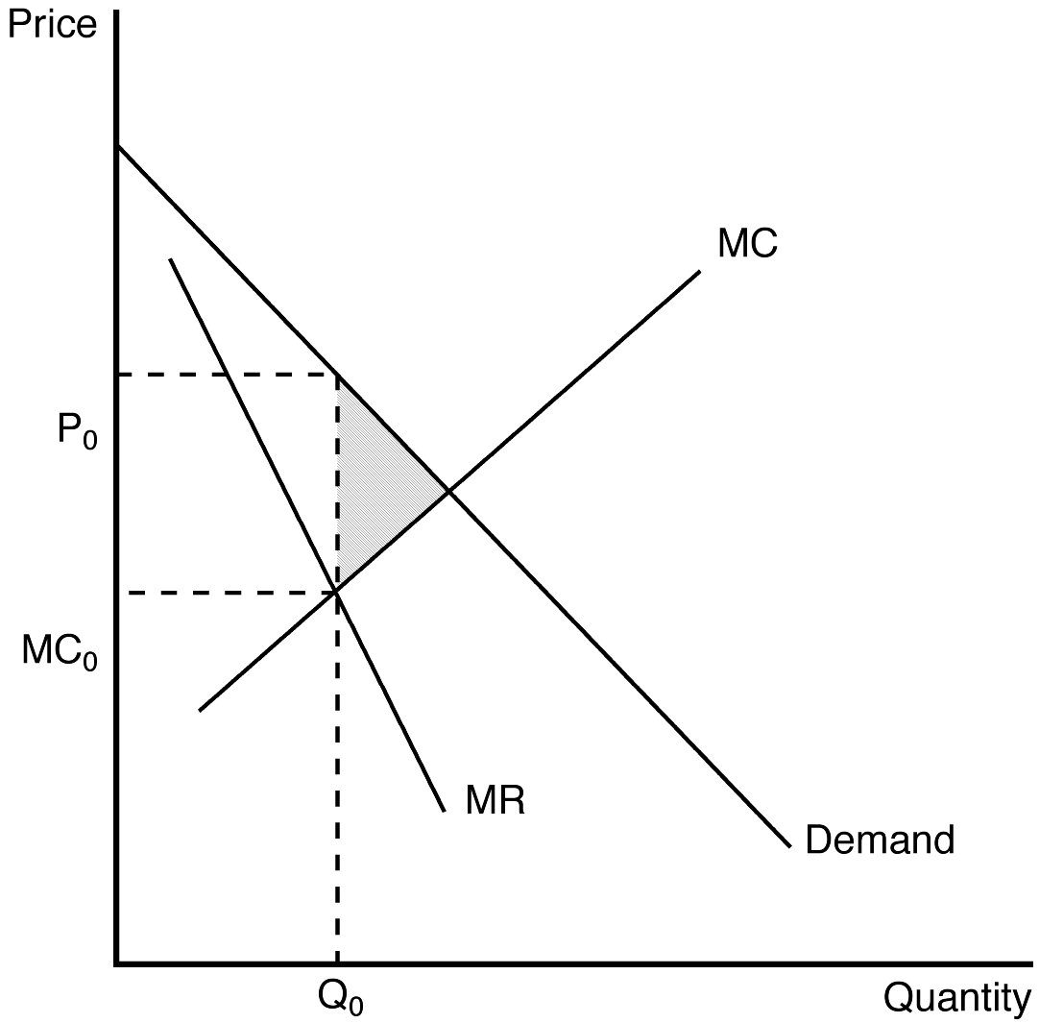
TYPE: S DIFFICULTY: 2 SECTION: 15.3
7. What is the deadweight loss due to profit-maximizing monopoly pricing under the following conditions: The price charged for goods produced is $10. The intersection of the marginal revenue and marginal cost curves occurs where output is 100 units and marginal revenue is $5. The socially efficient level of production is 110 units. The demand curve is linear and downward sloping and the marginal cost curve is linear and upward sloping.
ANSWER: $25
TYPE: S DIFFICULTY: 2 SECTION: 15.3
8. Why might economists prefer private ownership of monopolies over public ownership of monopolies?
ANSWER: The private monopolist is governed by the market. Even though the market solution is sub-optimal, it may be better than outcomes generated by publicly owned monopolies. Publicly owned monopolies may restrict output to levels below the private market outcome and thus generate an even lower level of social surplus than a private profit-maximizing monopolist. They also may not work to reduce costs.
TYPE: S DIFFICULTY: 2 SECTION: 15.4
9. In many countries, the government chooses to "internalize" the monopoly by owning monopoly providers of goods and services. (In some cases these firms are "nationalized" and the government actually buys or confiscates firms that operate in monopoly markets). What would be the advantages and disadvantages of such an approach to ensuring the "best interest of society" is promoted in these markets? Carefully explain your answer.
ANSWER: As long as the government "owner" pursues a production and pricing policy that approaches a competitive outcome, social well-being can be enhanced. In this case the government ownership would benefit society. However, in most cases, government owners operate much like private sector monopolists. The political economy of government institutions does not ensure that government owners will pursue socially optimal policy.
TYPE: S DIFFICULTY: 3 SECTION: 15.3
10. Let's assume that a monopolist decides to maximize revenue, rather than profit. How does this operating objective change the size of the deadweight loss? If you are a "benevolent" manager of a monopoly firm and are interested in reducing the deadweight loss of monopoly, should you maximize profits or maximize revenue? Carefully explain your answer.
ANSWER: A revenue maximizer operates where MR = 0. This solution moves the monopolist closer to the socially optimal competitive outcome, and reduces deadweight loss. Revenue maximization is potentially a more "socially" optimal objective for monopoly markets than profit maximization.
TYPE: S DIFFICULTY: 3 SECTION: 15.3
11. One solution to the problems of marginal cost pricing of a regulated monopolist is average cost pricing. In this model, the monopolist is allowed to price its production at average total cost. How does average cost pricing differ from marginal cost pricing? Does this solution maximize social well-being?
ANSWER: average cost pricing always guarantees that the monopolist earns zero economic profits, but does not ensure a socially optimal market solution.
TYPE: S DIFFICULTY: 3 SECTION: 15.4
12. What are the four ways that government policymakers can respond to the problem of monopoly?
ANSWER: Trying to make monopolized industries more competitive. Regulating the behavior of monopolies. Turning some private monopolies into public enterprises. Do nothing.
TYPE: S DIFFICULTY: 2 SECTION: 15.4
13. Explain the benefits and costs of antitrust laws.
ANSWER: Benefits: Promote competition by preventing mergers and breaking-up companies. Costs: May increase cost of operating by restricting synergy mergers.
TYPE: S DIFFICULTY: 2 SECTION: 15.4
14. Why do economists usually prefer private ownership to public ownership of natural monopolies?
ANSWER: Private owners have an incentive to minimize cost as long as they reap part of the benefit in the form of higher profit. By contrast, government bureaucrats have no incentive to reduce costs and the losers are customers and taxpayers, whose only recourse is the political system.
TYPE: S DIFFICULTY: 2 SECTION: 15.4
15. One example of price discrimination occurs in the publishing industry when a publisher initially releases an expensive hardcover edition of a popular novel, and later releases a cheaper paperback edition. Use this example to demonstrate the benefits and potential pitfalls of a price discrimination pricing strategy.
ANSWER: The answer should address the three basic lessons of price discrimination. First, price discrimination is a rational strategy that can lead to higher monopoly profits. Second, price discrimination requires an ability to separate customers according to their willingness to pay. Third, price discrimination can raise economic welfare.
TYPE: S DIFFICULTY: 2 SECTION: 15.5

